

Open Rack Standard V2.2

**Table of Contents**

Contents

License 7

1.0 Introduction 8

1.1 Purpose 8

1.2 Reference Documents 8

1.3 Compliance 8

1.4 Definitions 8

1.4.1 IT GEAR 8

1.4.2 IT TRAY 8

1.5 Overview of Open Rack 9

2.0 Mechanical Requirements 10

2.1 Frame Dimensions 10

2.2 OpenU Marking 10

2.3 IT GEAR Latch Depth 11

2.4 IT Support Shelves 13

2.5 Busbars 14

2.5.1 12V Busbar 14

2.5.2 48V Busbars 18

2.6 Rack level mechanical compliance requirement 19

2.7 Marking for Re-Use 19

3.0 Electrical Requirements 20

3.1 12V Open Rack Electrical Requirements 20

3.2 48V Open Rack Electrical Requirements 20

3.2.1 48V Rack Voltage 20

3.2.2 48V Grounding and Bonding 20

3.3 Rack-level Safety Standards 21

4.0 IT Interconnect to 12V BUSBAR 21

4.1 Mechanical 21

4.1.1 Dimensions for the 12V IT Interconnect 21

4.1.2 Dimensions for IT gear 23

4.2 Electrical 23

5.0 IT Interconnect to 48V BUSBAR 24

5.1 Features 24

5.2 Mechanical Intent and Dimensions 24

5.2.1 48V IT Gear Connector 24

5.3. Connector Function 26

5.4. Regulatory 27

6.0 48V IT Tray Power Spec 27

6.1 Introduction 27

6.2 Input Voltage level 27

6.3 Payload IT Tray Connector 27

6.4 Grounding 27

6.5 Safety Requirements on 48V and Related Nets 27

6.6 Input Fusing 28

6.7 CPU and Memory VRs 28

6.8 Other Power Rails VRs 28

6.9 Isolation 28

6.10 Power Off State 29

6.11 On/Off Control 29

6.12 Power Efficiency 29

6.13 VR Protection Levels 29

6.14 Thermal Requirement 30

6.15 Power Sequencing 30

6.16 Hot Swap 30

6.16.1 Input capacitors and protection components 30

6.16.2 Restart Function 30

6.16.3 Protection 30

6.16.4 Power Monitoring/Energy calculation 31

6.16.5 Telemetry 31

6.16.6 Power Good 31

6.16.7 Short Pin 31

6.16.8 Noise Sensitivity / Immunity 32

6.17 Firmware management 32

6.18 Tray safe removal 32

6.19 Compliance Requirements 32

6.19.1 EMC Requirements: 33

6.19.2 Safety Requirements 34

7.0 48V Power Shelf (rectifier and batteries) 35

7.1 Features 35

7.2 Physical Requirement 35

7.2.1 Power Shelf Assembly Dimension 35

7.2.2 Mounting 36

7.2.3 Construction 37

7.2.4 Materials and Fasteners 37

7.2.5 DC Output Labeling 37

7.3 Shelf Electrical Connections 37

7.3.1 Shelf input connections 37

7.3.2 Shelf DC connections 37

7.3.3 Shelf Grounding 37

7.3.4 Monitoring & Control Interface Connector 37

7.4 Compliance Requirements 38

7.4.1 EMC Requirements 38

7.4.2 Safety Requirements 39

8.0 12V Power Shelf 40

8.1 Features 40

8.2 Physical Requirement 40

8.2.1 12V Power Shelf Assembly Dimension 40

8.2.2 12V Mounting 41

8.2.3 12V Construction 42

8.2.4 12V Materials and Fasteners 42

8.2.5 12V DC Output Labeling 42

8.3 12V Shelf Electrical Connections 42

8.3.1 12V Shelf input connections 42

8.3.2 Shelf 12VDC connections 42

8.3.3 12V Shelf Grounding 42

8.3.4 12V Monitoring & Control Interface Connector 42

8.4 12V Compliance Requirements 43

8.4.1 EMC Requirements 43

8.4.2 Safety Requirements 44

9.0 Rack Management Controller (optional) 45

9.1 Minimum features of interface 45

9.2 Preferred features of interface 45

9.3 Interface inside power shelf with integrated rack management controller 45

Appendix A - 48V Rectifier Specification with Single Phase AC input 46

A.1 Features 46

A.2 Electrical Requirement 46

A.2.1 Application 46

A.2.2 Requirements Brief Summary 46

A.2.3 Electrical Requirements 46

A.3 Software Interface 49

A.3.1 Firmware Upgrade 49

A.3.2 Output Voltage / Current Control 49

A.3.3 DC Voltage Status 50

A.3.4 DC Current Status 50

A.3.5 DC Energy Status 50

A.3.6 Last Power Failure Fault Conditions 50

A.3.7 Rectifier Failure 50

A.3.8 Identification 50

A.3.9 Position 50

A.4 Compliance Requirements 51

A.4.1 EMC Requirement 51

A.4.2 Safety Requirements 52

A.5 Environment 54

A.5.1 Temperature 54

A.5.2 Humidity 54

A.5.3 Altitude 54

A.5.4 Acoustic Noise 55

A.5.5 Vibration 55

A.5.6 Shock 55

A.6 Thermals 56

A.6.1 Airflow Openings 56

A.6.2 Fan 56

A.6.3 Fan Failure 56

A.6.4 Temperature Sensors 56

A.6.5 Rectifier Thermal Monitoring 56

A.6.6 Rectifier Exhaust Temperature 56

A.7 Reliability and Quality 56

A.7.1 Derating Design 56

A.7.2 Reliability Prediction 57

A.7.3 Design Failure Mode and Effect Analysis (DFMEA) 57

A.7.4 High Accelerated Life Test (HALT) 57

A.7.5 Burn-In (BI) and Ongoing Reliability Testing (ORT) 57

A.7.6 Manufacturing Quality 57

Appendix B - 48V Battery Unit Spec 57

B.1 Features 57

B.2 Electrical Requirement 57

B.2.1 System Interface Electrical Requirements 57

B.2.2 Input / Output 58

B.2.3 Hot-swap 58

B.2.4 Inrush Current 58

B.2.5 Parallel Operation 58

B.2.6 Noise Immunity & Interference 58

B.2.7 Conductors, Grounding, and Isolation 59

B.2.8 Microcontroller(s) 59

B.2.9 Hazardous Energy 59

B.2.10 Internal Power Supplies 59

B.2.11 Fusing 59

B.2.12 Voltage, Current, and Temperature Accuracy 60

B.2.13 Charger 60

B.2.14 DC Resistance 60

B.2.15 Cell Balancing 60

B.2.16 Discharge 60

B.2.17 Operating States 60

B.3. Firmware Interface 60

B.3.1 Firmware Safety Considerations 60

B.3.2 Nonvolatile data 61

B.3.3 Remote Firmware Upgrade 61

B.4. Safety and Compliance 61

B.4.1 Safety 61

B.4.2 Agency Compliance 62

B.4.3 EMC 62

B.4.4 Proscribed Materials 63

B.5 Environment 63

B.5.1 Temperature 63

B.5.2 Humidity and Altitude 63

B.5.3 Acoustics 63

B.5.4 Mechanical Shock, Vibration and Drop 63

B.6 Physical Requirements 63

B.6.1 Construction 63

B.6.2 Cooling 64

B.7 Life and Quality 64

B.7.1 Expected Life 64

B.7.2 Derating 64

B.7.3 Initial Quality 64

Appendix C: 48V IT Tray to IT Gear Interfaces 64

C.1 IT Gear Horizontal Busbar Dimensions 64

C.2 Payload IT Tray Connector 66

Appendix D: Technical guideline- Rack shielding effectiveness target and measurement procedure 68

D.1 Shielding Effectiveness Measurements 68

D.2 Shielding Effectiveness Measurement Methodology 68

Revision History 69

# License

As of 15 JULY 2016, the following persons or entities have made this Specification available under the **OCPHL-P** , which is available [here](http://opencompute.org/participate/legal-documents/): Steve Mills Open Compute.org.

You can review the signed copies of the Contributor License for this Specification at on the OCP website which may also include additional parties to those listed above.

Your use of this Specification may be subject to other third party rights. THIS SPECIFICATION IS PROVIDED "AS IS." The contributors expressly disclaim any warranties (express, implied, or otherwise), including implied warranties of merchantability, non-infringement, fitness for a particular purpose, or title, related to the Specification. The entire risk as to implementing or otherwise using the Specification is assumed by the Specification implementer and user. IN NO EVENT WILL ANY PARTY BE LIABLE TO ANY OTHER PARTY FOR LOST PROFITS OR ANY FORM OF INDIRECT, SPECIAL, INCIDENTAL, OR CONSEQUENTIAL DAMAGES OF ANY CHARACTER FROM ANY CAUSES OF ACTION OF ANY KIND WITH RESPECT TO THIS SPECIFICATION OR ITS GOVERNING AGREEMENT, WHETHER BASED ON BREACH OF CONTRACT, TORT (INCLUDING NEGLIGENCE), OR OTHERWISE, AND WHETHER OR NOT THE OTHER PARTY HAS BEEN ADVISED OF THE POSSIBILITY OF SUCH DAMAGE.

# 1.0 Introduction

## 1.1 Purpose

By adhering to the following principles, the Open Rack fulfills the Open Compute Project goal of maximizing operational efficiency of large-scale deployments:

* Installation and service operations are located in the cold aisle
* Data cables are located on the front of the rack
* Component faults are identifiable from the front of the rack
* Routine service procedures do not require tools
* Non-recyclable components are minimized
* Designs are vanity-free
* Racks are integrated directly into data center air containment solutions

This standard defines the minimum required interfaces between the Open Rack and the equipment it supports to enable interoperability. The standard does NOT include all of the information necessary to completely define an entire infrastructure stack needed to deploy product. Each component, such as IT gear, power shelves, and PDUs for example, will have individual specifications that define their requirements. This allows different types of gear to be defined and developed for specific needs in the industry. While these product specifications do not need to be accepted or used by the entire industry, they all must comply to the standard to be considered Open Rack compliant.

## 1.2 Reference Documents

Open Compute maintains a list of approved project specifications available for public review on the [Open Rack Wiki](http://www.opencompute.org/wiki/Open_Rack).

A 3D CAD file of the standard cross-section is provided for download as a reference to help with the design of Open Rack on the [Open Compute Rack Project wiki](http://www.opencompute.org/wiki/Open_Rack/SpecsAndDesigns).

There is also a [Chassis Design Guide for IT Gear Builders](http://www.opencompute.org/wiki/Open_Rack/SpecsAndDesigns#IT_Gear_Builders) on the wiki as well.

## 1.3 Compliance

In order for any product to state compliance with this standard, the product must meet all of the requirements stated with the term SHALL and verified by an OCP certified lab. Any statements using the term SHOULD are recommendations for the design, but are NOT required features to show compliance.

## 1.4 Definitions

### 1.4.1 IT GEAR

IT Gear is defined as IT equipment installed in an Open Rack standard Equipment Bay that plugs directly into the live busbars. ‘IT Gear’ may also be a shelf that plugs directly into the busbars, and hosts multiple ‘IT Trays’ within the shelf. The shelf receives power from the Equipment Bay busbars with one connector clip pair, and distributes the power to the ‘IT Trays’ installed within the Shelf.

### 1.4.2 IT TRAY

IT Tray is defined as sub-component of the ‘IT Gear’ that may consist of one or more motherboards on individually removable metal trays or sleds. The mechanical and fit functions of the Open Rack standard apply only to the ‘IT Gear’ that plugs directly to an Open Rack bus bar system. The electrical requirements, however, apply to both ‘IT Gear’ and ‘IT Trays’

## 1.5 Overview of Open Rack

Open Rack is divided into three zones as shown in Figure 1:

* A Cable zone facing the cold-aisle side of the data center
* An Equipment Bay in the middle for all of the equipment
* A Power and Cooling zone on the hot-aisle side of the data center

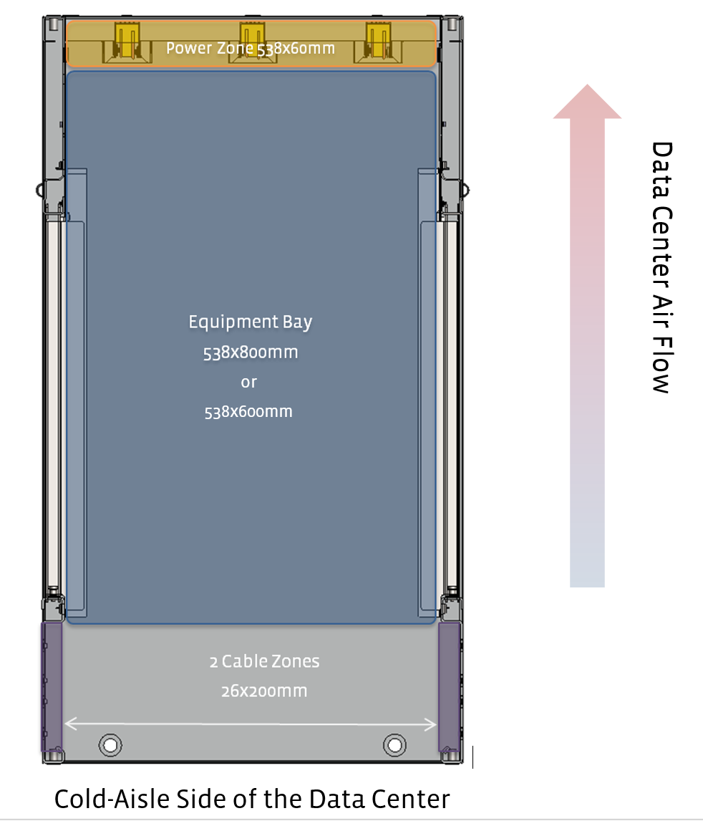

Figure 1: Top View of the Deep Depth Open Rack

The Cable zone, located at the front of the rack, manages and protects the data cables connected to the IT equipment. Technicians can add and remove equipment from the rack without standing in the hot-aisle to perform routine service.

The Equipment Bay is approximately 538mm wide. During installation, the equipment slides past the cable zone and rests on a series of horizontal support shelves within the rack. Once on the support shelves, a DC connector in the equipment blind-mates into the bus bars in the Power/Cooling zone.

The Power/Cooling zone in the rack consists of one or more pairs of bus bars that transmit power from a rack level power shelf to the equipment. The vertical bus bars connect the equipment with the rack-level power sub-system located either above or below the Equipment Bay. The system is designed so that equipment in the Equipment Bay can attach to the bus bar continuously along its entire length to accommodate chassis of different sizes over multiple generations. Optionally, this zone could also include rack-level cooling fans, a rack level management system, data fabrics, and PDUs.

Integrated together, these components combine to create a self-contained eco-system optimized for hyper-scale computing.

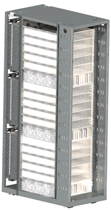

Figure 2: Open Rack Assembly Example

# 2.0 Mechanical Requirements

The standard allows for 2 different depths of IT Gear: ~800mm (the original depth from revision V1.1), and a new modular shallow depth of ~660mm. The original IT Gear depth targeted a rack depth of 1048mm (though any depth is acceptable). The modular shallow derivation of the Open Rack features a shallow base rack depth with options for a modular front extension for cable management and security provisions. The desired rack depth for the shallow variant is 762mm [30.0in] from front to back. The rear retention portion of the rack will remain common with the Open Rack v1.2 standard. External Width and Height are not specified, as they can vary depending on application.

## 2.1 Frame Dimensions

The vertical columns in the rack help retain equipment and also limit its horizontal movement. This enables the chassis to align the bus bar clip to the bus bars.

As the equipment is installed into the rack, it will stop against a series of lances in on the hot-aisle side of the rack frame. The lances keep the equipment from falling out the back of the rack when moving the rack or servicing equipment. The lances also provide several millimeters of air gap between the back of the equipment and the bus bars. This air gap prevents shock loads from damaging the bus bars.

Once the equipment is installed, the rack frame equipment has a series of rectangles along the front vertical frame that can be used to prevent the equipment from moving forward. Equipment designers can use these rectangles when designing retention schemes that help technicians quickly remove equipment. For example, equipment that does not weigh much could use simple metal spring latches to grab into the rectangle. Heavier equipment might use a thick cam lever with a positive latch for retention.

The rectangles and lances used to retain the equipment repeat twice every 48 mm. This 48mm pitch is defined as an OpenU.

## 2.2 OpenU Marking

Each OpenU on the rack:

· SHOULD be numbered so people can easily identify the exact location of the equipment.

· SHALL be sequentially numbered in a permanent and legible manner starting with the number one (1) in the bottom of the rack.

· SHOULD be numbered in a location where cable bundles and equipment will not hinder its visibility.

## 2.3 IT GEAR Latch Depth

The IT Gear latch depth is defined as the distance between the hard stop lance in the back and the latching surface of the 14x18mm rectangle in the front (Datum A**)**. As defined in Figure 3, the Open Rack Standard allows for only 2 IT Gear latch depths: 645mm and 789.6mm.

In order to comply with this standard, the vertical columns of the rack SHALL contain the features defined below and displayed in Figures 3a and/or 3b, as well as Figures 4, 5 and 7:

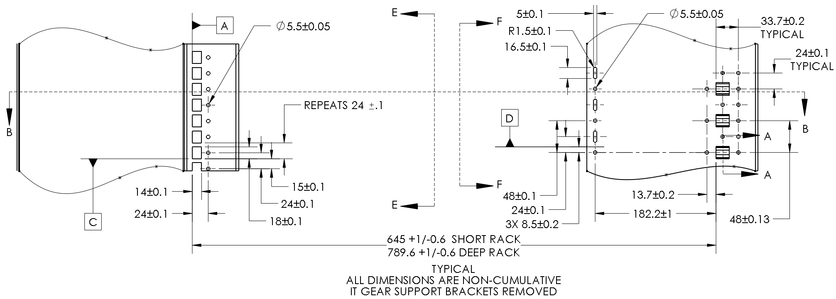

Figure 3a: Open Rack Frame Detail

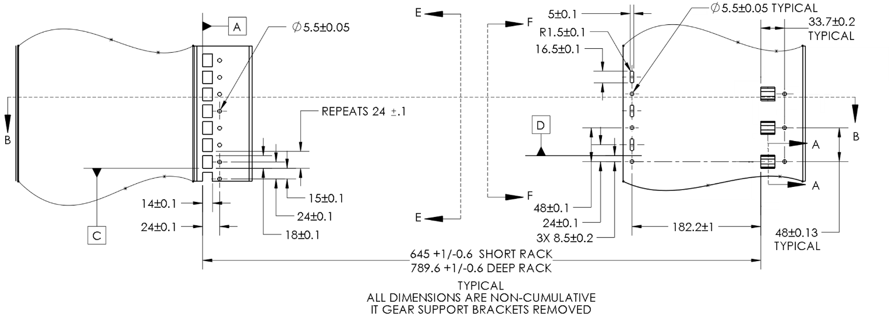

Figure 3b: Open Rack Frame Detail

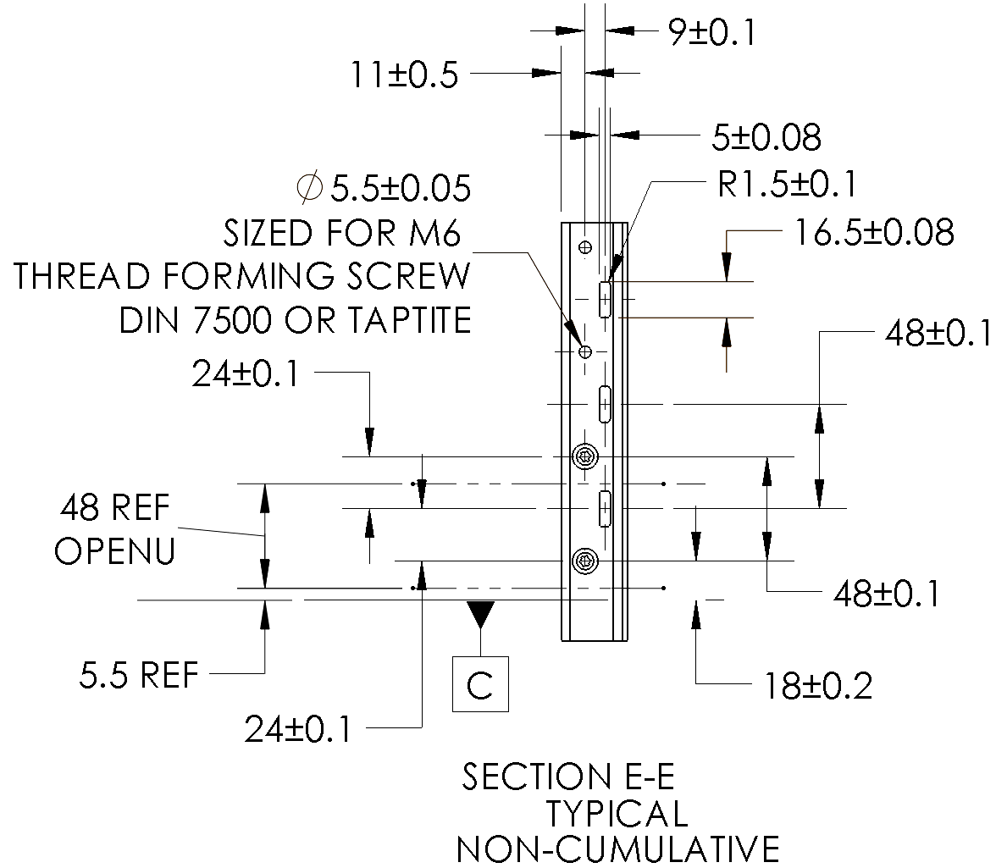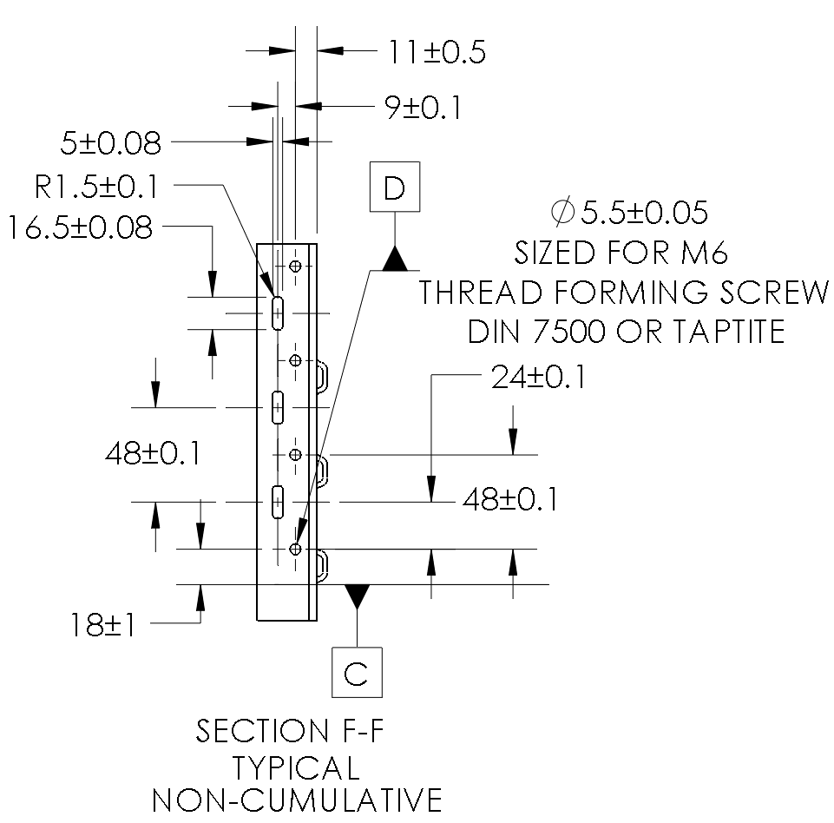

Figure 4. Front and Rear Vertical Post Detail

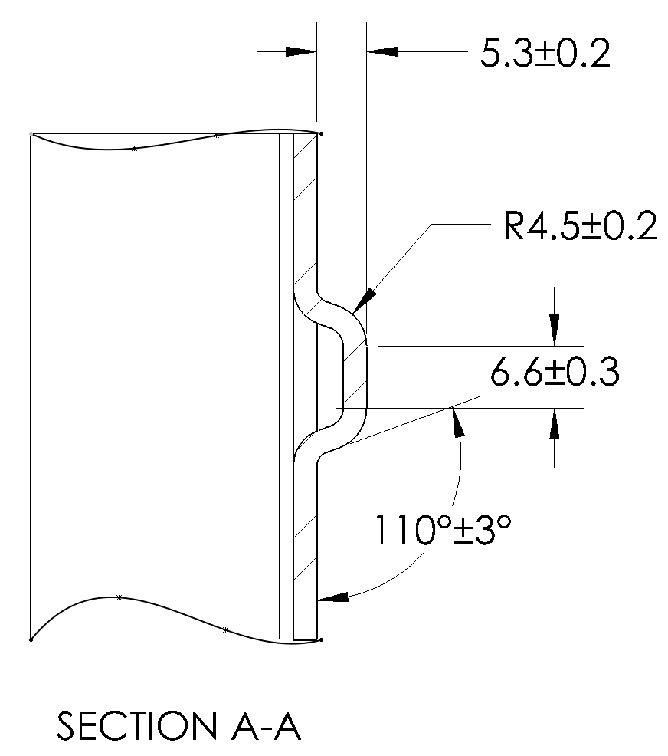

Figure 5: Open Rack Rear Stop Detail

## 2.4 IT Support Shelves

The IT equipment sits on a series of horizontal support shelves. These shelves could be constructed as individual brackets that are assembled into the rack, or incorporated into the rack structure itself by creating them out of the sides of the rack. The quantity (which may be zero) and vertical locations of the shelves are left to the customer to specify.   
The IT Support Shelves SHALL:

* Support equipment as small as 1 OpenU tall (48mm)
* Conform to the shape shown in Detail C (Figure 6). If the IT Support Bracket is continuous along the entire width of the rack instead of two Support Brackets, than the 20mm bracket length in Detail C may be ignored.
* Provide a continuous ground path from the equipment to the Open Rack frame per UL50 after 48 hours of salt spray per ASTM B117-07
* Have a finish that does not encourage the growth of metal whiskers
* Be recessed between the vertical posts so that the 538mm equipment bay width is not reduced
* Support an evenly distributed load of at least 700N load per pair without taking a permanent set.

The pair of IT Support brackets SHOULD:

* Have a pre-plated hot-dip zinc coating conforming to ASTM A653 or JIS 3302 SGOC or be post-plated

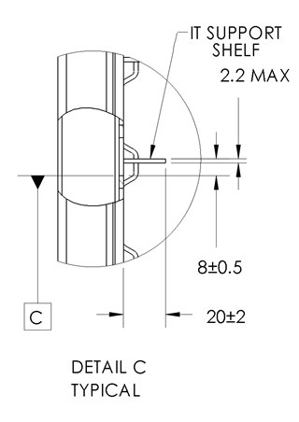Figure 6: IT Support Bracket Detail

## 2.5 Busbars

The bus bars are located in the back of the rack and transmit the power from the rack-level power sub-system to the It Gear in the equipment bay of the rack. The bars allow the equipment to plug directly into the power so the technician does not need to go to the back of the rack to disconnect power cords prior to servicing equipment.

The bus bar cover protects people from the positive bus bar when the rack is powered-up. Access to the front of the bus bar shall be limited by the design of the equipment and/or a blank to fill any empty equipment location in the rack.

A volume around each bus bar is reserved for an optional busbar cover to protect people. Shelf-level busbars for connecting IT Trays shall also be protected. While protecting people is not optional, the methodology is. For example, a single hinged panel could cover the entire back of the rack rather than using individual covers around each bus bar set.

The Bus bars SHALL:

* Be populated with either one or three bus bars per power zone
* Be located in the center position in the rack if only a single bus bar pair is populated
* Be located in the rack per Figure 7 and comply with Figure 8
* Be silver plated at interface points.
* Have user access limited by a method that conforms to UL 60950
* Be made of copper with an IACS near 100%
* If individual bus bar covers are used, the bus bar covers SHALL:
  + Stay within the zone defined in Figure 8
  + Have a perforated surface behind the bus bars that has a minimum of 40% opening after any support, insulators, or labels are included (Figure 8)
  + Have perforations and/or service panels that conform to UL 60950

The Bus bars SHOULD be designed so that they can be removed and re-installed by a trained service technician in the field.

### 2.5.1 12V Busbar

#### 2.5.1.1 Dimensions

The 12V Busbar SHALL be located in the rack per Figure 7 and comply with Figure 8.

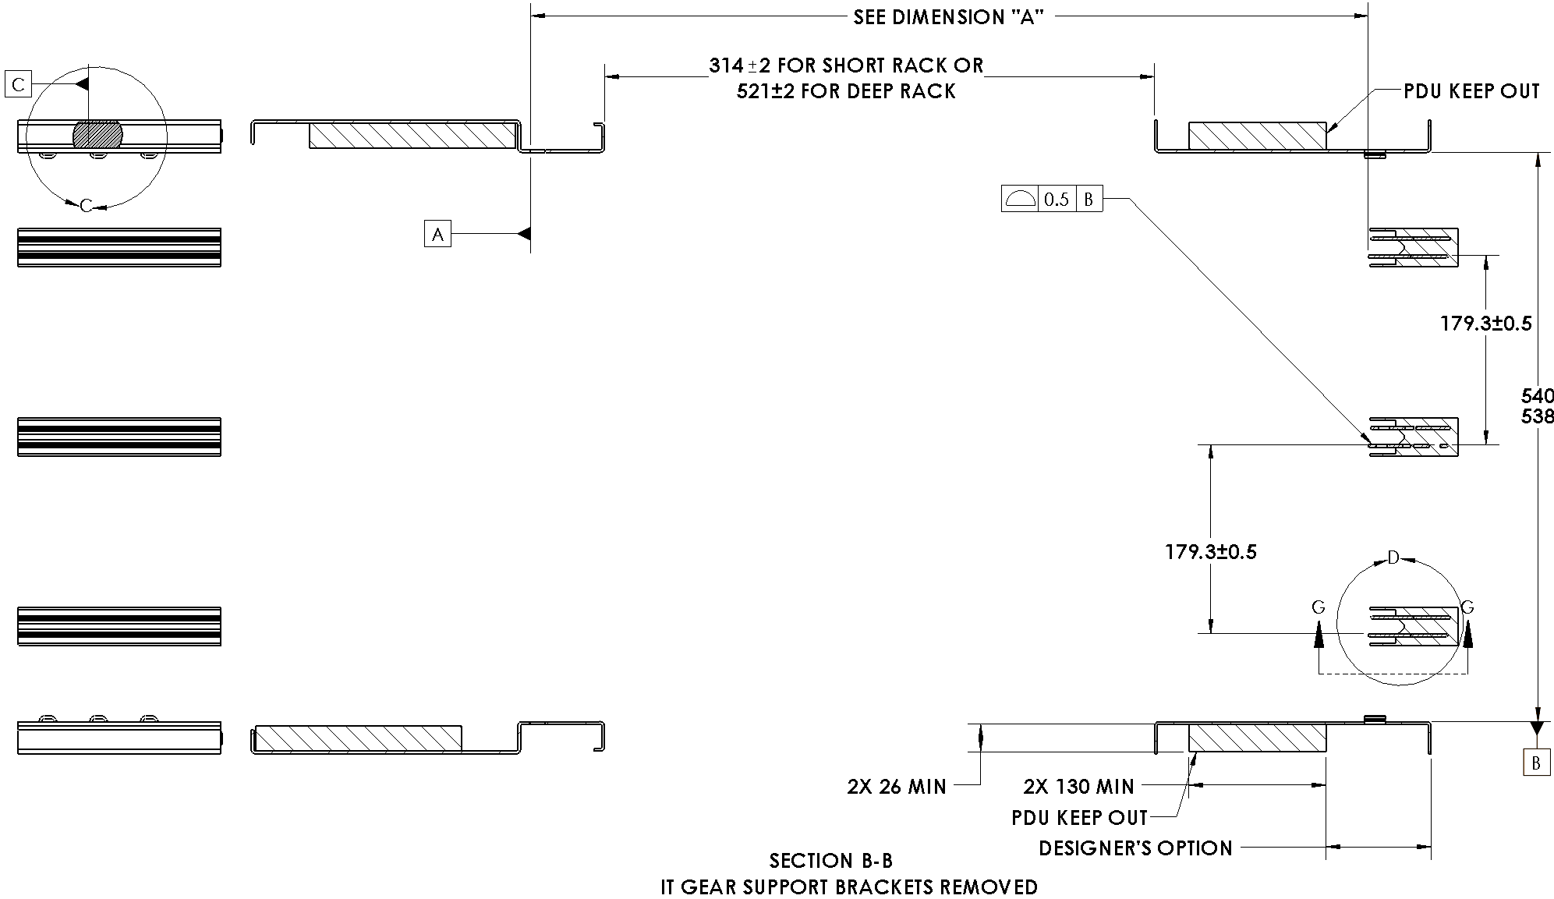

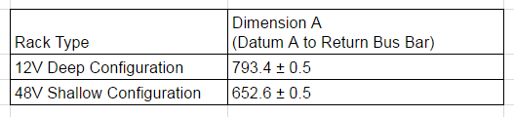

Figure 7: Open Rack Cross-Section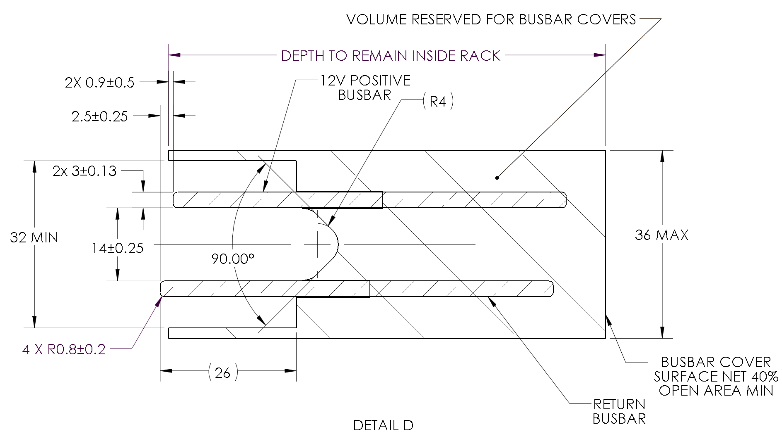

Figure 8: 12V Busbar Detail

#### 2.5.1.2 12V Power Shelf Connections to the Busbar

The quantity of bolted bus bar connections between the power subsystem and Open Rack is variable based on the power and efficiency expected of the rack. The number of possible connections increases in a 25mm grid pattern as defined in Figure 9a and 9b.

Any bolted connections to the rack SHALL:

* Be located in the rack as shown in Figure 9a or 9b.
* Consist of a minimum of two connections as shown by the black rectangle in Figure 9.

Additional locations can be added in the following order as shown in Figure 9:

* 4 holes in a square pattern shown in red
* 6 holes in a rectangular array as shown in blue
* 9 holes in a square pattern as shown in green

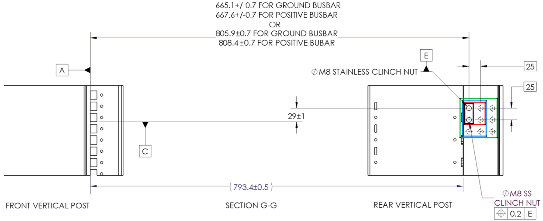

Figure 9a: 12V Power Shelf to Rack Busbar Interconnect location

(Note: Refer to Figure 7 and Section 2.4.2.1 for 12V Bus Bar location)

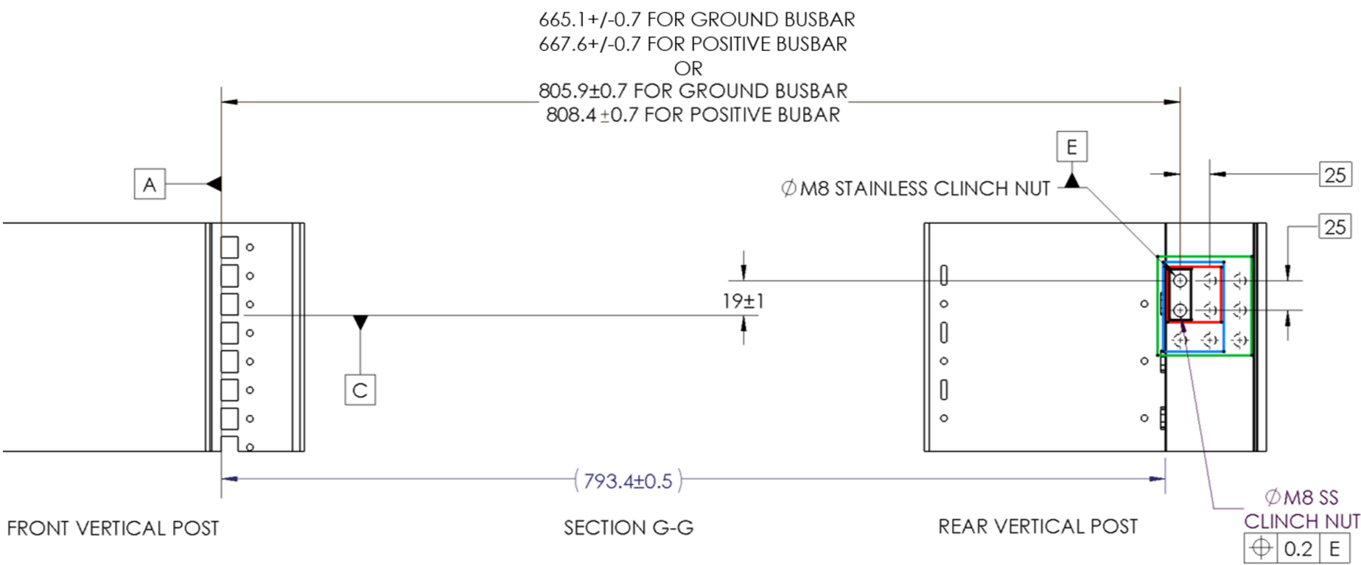

Figure 9b: 12V Power Shelf to Rack Busbar Interconnect location

(Note: Refer to Figure 7 and Section 2.4.2.1 for 12V Bus Bar location)

### 2.5.2 48V Busbars

#### 2.5.2.1 Vertical Rack-Level Busbar Dimensions

Busbar locations and mounting points are shared with the 12V busbar. The busbar will be designed for the intent of a busbar-as-a-module, allowing for a retrofit of the 12V busbar for a 48V busbar. The busbars will not be connector-compatible to prevent installation of a 12V IT Gear payload into a 48V rack system.

The location of the front-most edge of the 48V Power busbar from the Datum A locking point is 654.1mm [25.75in]. The location of the front-most edge of the 48V Return busbar from the Datum A locking point is 652.6mm [25.69in].

* The Rack-level PDBB distributes power vertically along the height of the rack.
* The PDBB will be mounted within the vertical busbar mounting bracket
* The interface will provide Power and Return.
* Definition of the PDBB cross-sectional profile will drive the design of the vertical IT Gear connector.

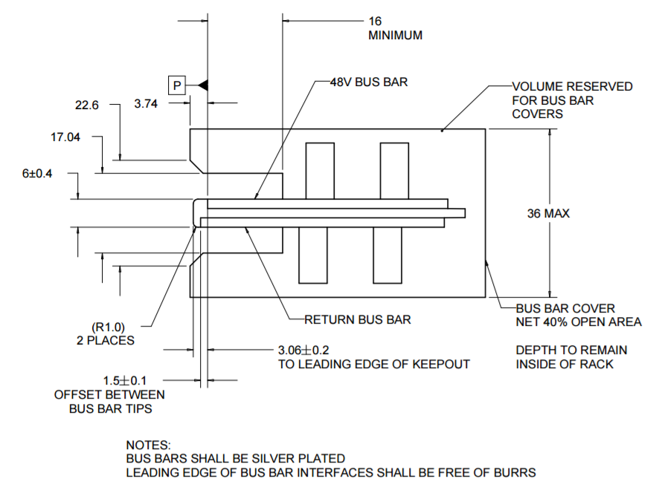

Figure 10: Top View of 48V Busbar Detail

#### 2.5.2.2 48V Power Shelf Connections to the Busbar

The quantity of bolted bus bar connections between the power subsystem and Open Rack is variable based on the power and efficiency expected of the rack. The number of possible connections increases in a grid pattern as defined in Figure 11.

Any bolted connections to the rack SHALL:

* Be located in the rack as shown in Figure 11.
* Consist of a minimum of two connections as shown by the black rectangle in Figure 11.

Additional locations can be added in the following order as shown in Figure 11:

* 4 holes in a square pattern shown in red
* 6 holes in a rectangular array as shown in blue

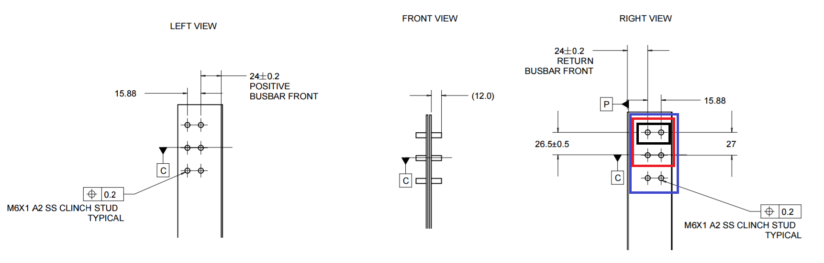

Figure 11: 48V Power Shelf to Rack Busbar Interconnect location

## 2.6 Rack level mechanical compliance requirement

The mechanical rack is to be designed to comply with the latest edition, revision, and amendment of Rack level UL 2416 compliance requirement.

## 2.7 Marking for Re-Use

The lifecycle of the rack is normally significantly longer than the equipment inside it. Ideally the rack would be used for multiple generations of equipment. The maximum load rating of the rack frame and the IT Shelves, however, is not controlled by this standard. Thus, when it is time to re-purpose the rack for future equipment, it is necessary to know the limits of the rack.

The load rating SHOULD be located so it is visible from the cold-aisle of the rack.

The rack SHALL be marked:

· In a permanent and legible manner with the maximum load mass (in kilograms) that the IT Support shelves and the rack frame are capable of supporting (whichever is less) under Telcordia GR63 Zone2.

· With the latest revision number of the standard for which the rack is compliant in either of the following formats:

o OPEN RACK STANDARD REVXX.X

o ORS REVXX.X

Where “XXX” is the alphanumeric version of the specification such as: V1.0 or V2.2

· In a location that is visible without removing equipment

· In a location that will not be damaged by equipment sliding in and out of the rack during routine service

For purposes of qualification testing, the total mass used for determining the frame load rating SHALL be evenly distributed within the entirety of the equipment bay.

# 3.0 Electrical Requirements

The following requirements pertain to a populated Open Rack system when the Rack contains IT Gear and Power Shelves.

## 3.1 12V Open Rack Electrical Requirements

The busbar(s) in an Open Rack Compliant system:

· SHALL have a voltage of 12.2V ±0.4V average DC (Hz bandwidth) at any point along the entire length of the bars with any configuration of the loads and any physical distribution of the IT Gear along its length.

· SHOULD have an output voltage is 12.5V ±0.1V at the connections to the bus bar pair(s).

· SHOULD be sized for a current density at full load not higher than 5 Amps / mm2. The recommended bus bar current density at full load is 3.5 Amps / mm2 (or lower) which will limit the conduction losses and also guarantee optimum dynamic performances of the bus bar pair during heavy dynamic loads.

The bus bars of an Open Rack system SHALL NOT:

· Be electrically connected to the rack system metal frame (chassis ground)

· Have the positive bus bar connected to the chassis ground

· Have the negative bus bar connected to the chassis ground

## 3.2 48V Open Rack Electrical Requirements

The 48V Open Rack Power Architecture is comprised of centralized scalable power shelves that distributes power over a common bus bar to the payload devices (IT Gear) . The key specifications for the 48V DC bus are outlined below:

### 3.2.1 48V Rack Voltage

DC Bus Operating Voltage Range: +40V to +59.5V DC

DC Bus Nominal Voltage: +54.5V

The assembled busbar assembly must comply with the following:

HiPot power to return busbar after assembly

2.4kV, 10 second ramp, 10 second hold

Max 10uAmp leakage current

### 3.2.2 48V Grounding and Bonding

48V return to be connected to Chassis Ground at Power Shelf level

Zero Volts on mobo also connected to chassis ground. In case of non-isolated 48V to PoL, this effectively means that the 48 RTN is also connected to chassis.

## 3.3 Rack-level Safety Standards

Both the 12V and 48V racks are to be designed to comply with the latest edition, revision, and amendment of the following standards. The rack shall be designed such that the end user could obtain the safety certifications.

* [USA] UL 60950-1, Information Technology Equipment - Safety - Part 1: General Requirements
* [CAN] CAN/CSA C22.2 No. 60950-1, Information Technology Equipment - Safety - Part 1: General Requirements
* [INT’L] IEC 60950-1, Information Technology Equipment - Safety - Part 1: General Requirements, including all national deviations as specified in the most current CB Bulletin; CB Certificate and report MUST include all countries participating in the CB Scheme; US and Canada national deviations may be excluded since the power supply will have third party certifications for these 2 countries
* [EU] EN 60950-1, Information Technology Equipment - Safety - Part 1: General Requirements
* IEC 62368-1, Audio/video, information and communication technology equipment – Part 1: Safety requirements (applicable to meet anticipated effective date of June 20, 2019 for North America and Europe.)

# 4.0 IT Interconnect to 12V BUSBAR

## 4.1 Mechanical

## 4.1.1 Dimensions for the 12V IT Interconnect

The IT Gear connector is attached to the rear wall of the IT Gear and delivers the power from the 12V busbar to the IT GEAR. The clip floats +/-3mm vertically and +/-2 horizontally to prevent damage due to movement of the IT GEAR during transit in the rack. The panel openings can be adjusted to allow smaller float amounts if desired.

The 12V Interconnect SHALL comply with Figure 12 and Figure 13.

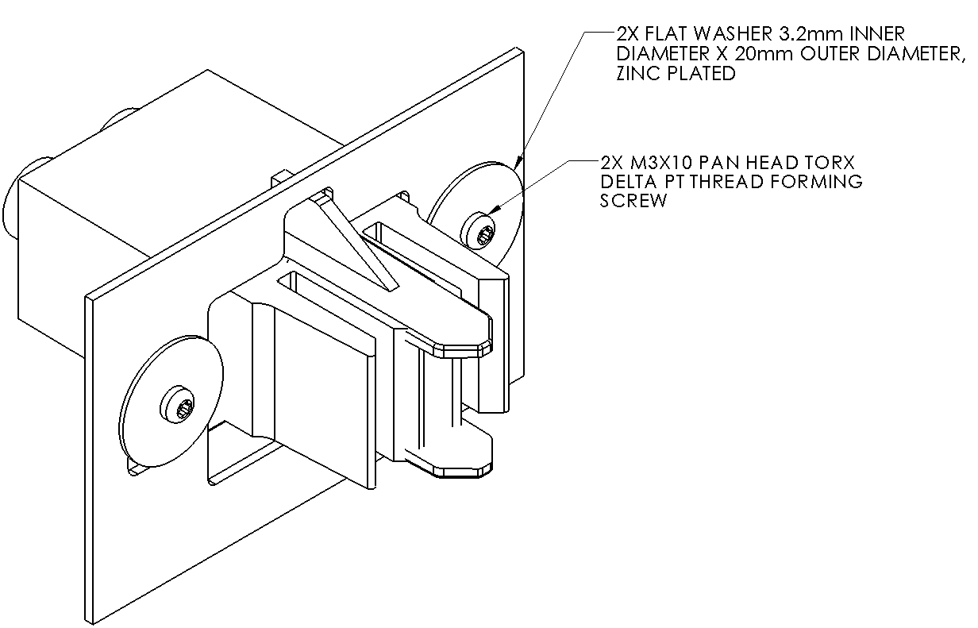

Figure 12: 12V IT Gear connector mounted to rear panel

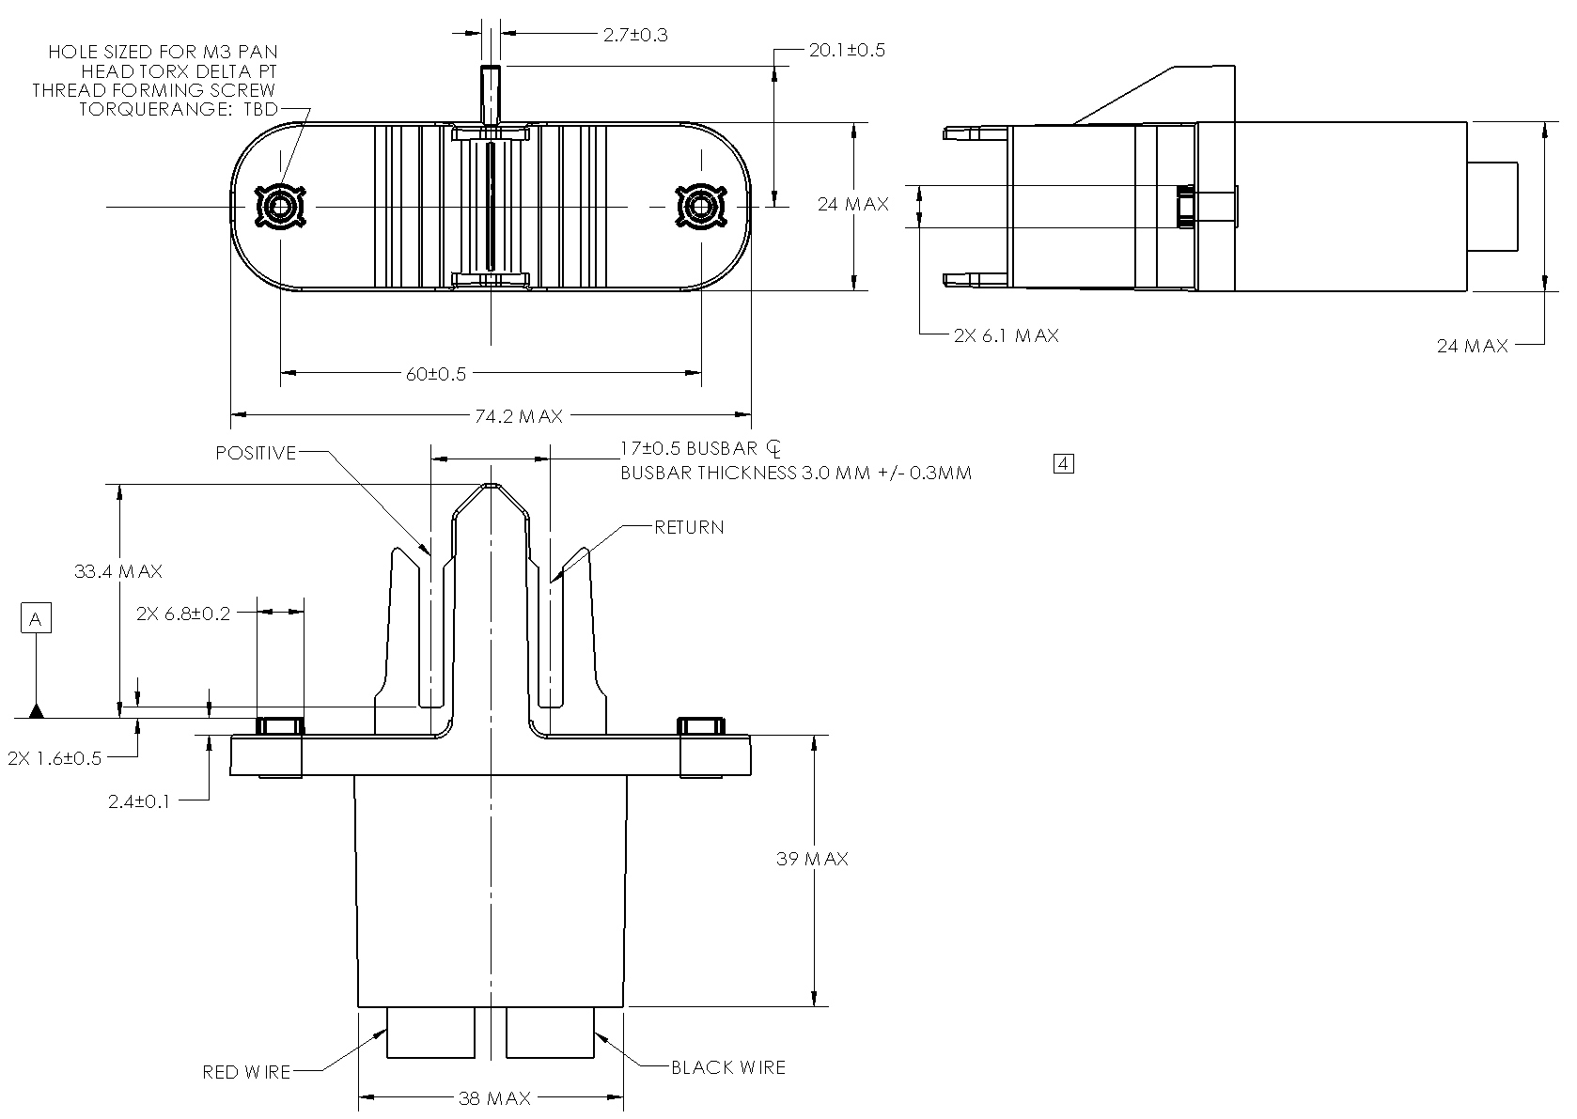

Figure 13: Dimensions of 12V Busbar connector [mm]

### 4.1.2 Dimensions for IT gear

The cut out of for the IT Gear to allow for a 3mm float in the vertical direction and 2mm in the horizontal direction is defined in FIgure 14.

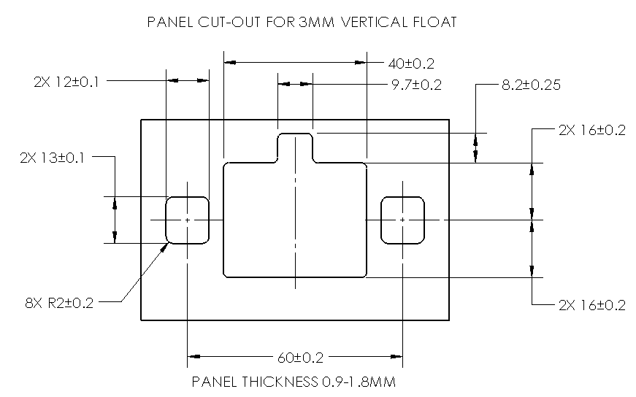

FIgure 14: IT Gear cut-out for 3mm connector float for 12V connector

## 4.2 Electrical

Contact Resistance <0.5mΩ EIA-364-6

Temperature Rise 30C Max @ rated current EIA-364-70, Method II

Insertion force < 40N EIA-364-13

Float >2mm

Contact retention 140N EIA-364-29

Salt Spray 48 hours, with a 5% solution salt spray, at 35 +1/-2°C

Vibration 0.5g, 1.5mm amplitude, 5-500 Hz, 10 sweeps @ 1 octave/minute in all orthogonal axes with no

discontinuities > 1 microsecond

Shock 50G half-sine@ 11ms for 3 orthogonal axes EIA-364-27, Method A.

Regulatory UL94V0

# 5.0 IT Interconnect to 48V BUSBAR

## 5.1 Features

This specification will define a 48V payload to Power Distribution Busbar (PDBB) interconnect system. The interconnect solution serves two purposes: connecting IT Gear directly to the rack-level PDBB and connecting IT Trays to a shelf-level PDBB. See Appendix C for detail regarding IT Tray connector interface.

## 5.2 Mechanical Intent and Dimensions

### 5.2.1 48V IT Gear Connector

IT Gear Connection to Vertical Rack-level PDBB

* The IT Gear connector is intended to tie payloads to a vertical, rack-mounted PDBB.
  + The IT Gear connector is designed to be able to attach to the bus bar at any location along its length (pitch agnostic).
  + When mounted in the vertical orientation, the connector will connect an IT Gear payload to the Rack-level vertical PDBB.
  + The IT Gear wire mount connector shall be mountable onto a panel or installed directly to the shelf-level PDBB and shelf assembly
* The IT Gear connector shall consist of 3 connections: Return, Power, and Short Pin.
  + The Power and Return contacts are to be coplanar, as contact order is determined via busbar offset
* The make sequence shall be: Return > Power > Short Pin.
* The break sequence shall be reverse of make (short pin disconnects first, then power, last return).
* The opening on the IT Gear SHALL comply with Figure 16.

The IT Gear connector is attached to the rear wall of the IT Gear or payload shelf and delivers the power from the 48V busbar to the IT GEAR or shelf-level PDBB. The clip floats +/-2mm both vertically and horizontally to prevent damage due to movement of the IT Gear during transit. Thread-forming screws and a pair of washers are used to retain the connector in the chassis. The height of the boss on the connector body ensures that the connector will float along the rear wall of the IT Gear as shown in Figure 15.

Not Available yet.

Figure 15: IT Gear connector mounted to rear panel

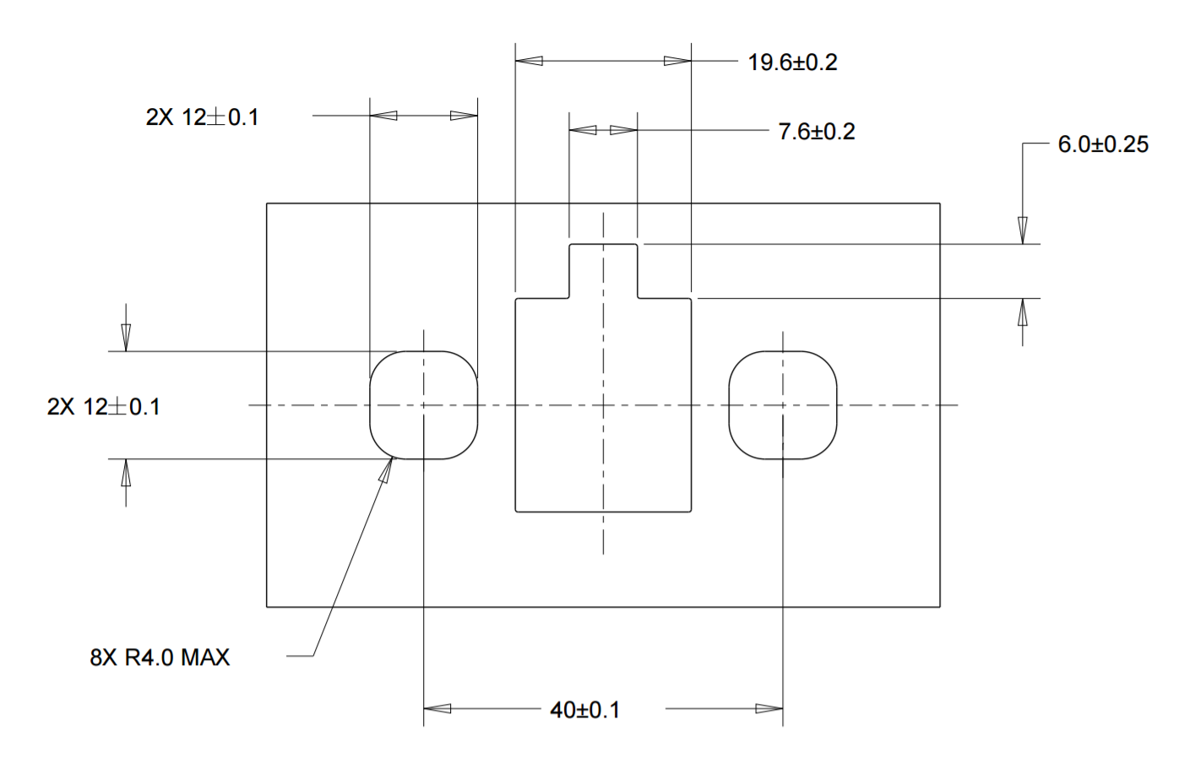

Figure 16: 48V IT Gear cut-out for rear panel

The 48V Interconnect SHALL comply with Figure 17 and all requirements detailed in section 5.3 and 5.4:

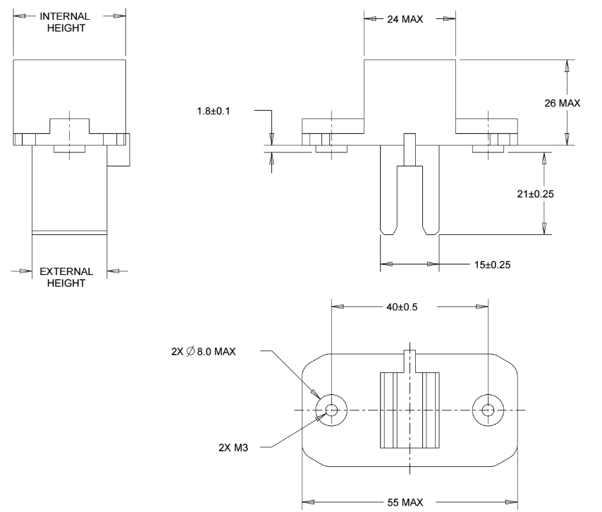

Figure 17: 48V IT Gear connector to rack-level busbar

## 5.3. Connector Function

Contact Resistance <0.3mΩ BOL, <0.45 mΩ EOL per contact

Lifecycles Minimum 80 non-operating cycles with <10% increase in resistance

Operating Temp 10C-60C

Temperature Rise 30C Max @ rated current EIA-364-70, Method II

Insertion force < 40N EIA-364-13

Float >2mm

Contact retention 140N EIA-364-29

Salt Spray 48 hours, with a 5% solution salt spray, at 35 +1/-2°C

Vibration 0.5g, 1.5mm amplitude, 5-500 Hz, 10 sweeps @ 1 octave/minute in all orthogonal axes with no

discontinuities > 1 microsecond

Shock 50G half-sine@ 11ms for 3 orthogonal axes EIA-364-27, Method A

## 5.4. Regulatory

All materials shall be UL94V0 rated.

Connectors shall be UL1977 recognized

# 6.0 48V IT Tray Power Spec

## 6.1 Introduction

The goal of this document is to outline the core power requirements for a 48V payload tray (e.g. server, storage tray, networking switch, etc.) consistent with the overarching 48V System Specification. This document contains the superset of payload power requirements that may be leveraged by all 48V based payload designs.

## 6.2 Input Voltage level

* Nominal level: +54.5V DC
* Range: +40V to +59.5V DC

The (rack) system uses an always-on power supply with voltage delivered over a common bus bar that provides a fixed voltage to payloads in the range +40V to +59.5V. All payload voltage regulators must be designed to support this input voltage range.

## 6.3 Payload IT Tray Connector

The Payload connector must contain the following pins:

* 48V Positive
* 48V Negative Return
* Chassis Ground
* Hot Swap Enable

A fuse or fusible resistor shall be directly connected to the positive 48V input connector pin and followed by a hot-swap circuit as described subsequently below.

Note: See Appendix C for detail regarding IT Tray connector interface

## 6.4 Grounding

At the Payload Input, the Chassis GND connection from the 48V input power connector shall be connected via a copper shape to the closest standoff or mounting hole which will provide a connection to the machine’s sheet metal when assembled. The ground copper shape cross-sectional area shall be equivalent to the 48V input power cross-sectional area.

Payload Secondary Grounding - All remaining mounting holes on the board will be electrically connected to the VR (Voltage Regulator) output own negative return. Each VR output shall connect to grounding at least once.

## 6.5 Safety Requirements on 48V and Related Nets

Payload PCB Spacing and Keep Outs

The high potential difference between the nominal 48V positive, negative return and GROUND nets necessitates strict spacing requirements. The concern is that manufacturing defects can result in a fault where there is a short across two nodes with a large difference in potential. The large difference in potential is defined by any voltage differential between 40V to 59.5V. This dissipation of energy can result in fire. The requirements around these high potential nets are:

* All internal layers to have a minimum of 0.64 mm clearance between signals with high potential difference
* External layers (Top and Bottom of PCB) to have a minimum of 1.5 mm clearance between signals of high potential difference if the signals are after the main board fuse from the power input connector
* External layers (Top and Bottom of PCB) to have a minimum of 3.0 mm clearance between signals of high potential difference if the signals are before the main board fuse at the input power connector, so the nominal 48V POWER and RETURN at the power input connector, for example, need to have 3.0 mm clearance.
* In the Z-axis, high potential signals before the fuse must have minimum 0.43 mm spacing or 3-ply prepreg. For signals after the fuse, minimum 0.076 mm spacing must be provided.

Exceptions may be necessary due to inherent spacing of components. These exceptions needs to be fully evaluated with DFMEA on the case by case basis.

## 6.6 Input Fusing

Input fuse shall take the following factors into account:

* Voltage Rating: 80V DC minimum
* Current rating: choose based on payload power loading considerations.
* Interrupting Rating: (aka breaking capacity) fuse must have an interrupt rating equal to or greater than the maximum available instantaneous short circuit current on the rack power bus providing power to the payload.
* Overload Considerations: The fuse shall have a minimum current threshold rating at which the fuse will open during overload conditions based on the time/current curve of the fuse without damage.
* Fuse Placement: Location of the fuse is to be as close to the input power connector as feasible.

## 6.7 CPU and Memory VRs

It is recommended to utilize 48V-to-PoL power conversion circuits for CPU, high power ASICs and memory power rails. The whole system TCO, efficiency analysis should be done case by case for the VR selection.

## 6.8 Other Power Rails VRs

There are many ways to design the VR solution for all other (lower power) power rails except CPU and memory. A direct 48V-to-PoL converter can be used if high efficiency can be obtained, or 48V can be converted to an intermediate voltage (for example 12V) by standard brick or other similar power converter before converting to point of load through downstream VRs.

## 6.9 Isolation

As was explained above, the main system bus voltage range is from +40V to +59.5V, which is a IEC defined SELV (Safe Extra Low Voltage). Therefore, there is no requirement for isolation from a safety point of view. Non-isolated converters are usually easy to design, cheap and smaller, but isolated converters potentially enhance noise immunity and may limit failure zone size. Whether or not isolation is necessary in a given design may be determined by considering grounding requirements, noise immunity, affection of potential re-circulation currents, etc. on a case by case basis.

## 6.10 Power Off State

When the system is off, none of the voltage rails (except the standby voltages) shall be generated. The hot swap power cycle (power off and then power on through hot swap) shall be longer than the discharge time of all the power rails. Bleed resistors may be required to guarantee the decay time constants.

## 6.11 On/Off Control

System power on/off may be controlled by application/OS software, ACPI (Advanced Configuration Power Interface), or manually by means of a power button.

## 6.12 Power Efficiency

The most stringent power efficiency requirements are for the CPU and Memory power rails which usually dominate the power consumption. The efficiency for the CPU shall be higher than 94% at TDP point for VRM output voltage equal to 1.8V and 89% at TDP point for VRM output voltage equal or less than 1V measured from input at 54.5V to the output.

In general, the target efficiency for VRs that deliver greater than 10W is at least 92% over 30% to 90% load range. Otherwise 85% efficient is acceptable for loads less than 10W. LDOs can be used for very small power rails (Less than 3W) that do not require to meet an efficiency target.

## 6.13 VR Protection Levels

All the VRs must have output short circuit and overcurrent protection. The overcurrent rating is usually set from 120% to 200% of the maximum load current and the OCP (Over Current Protection) shall never trigger under normal operating conditions including high peak dynamic current from the load.

In the payload input voltage range of +40V to +59.5V, the VRs shall be capable of meeting the full power requirements of the load. The VR input Under Voltage Protection level shall be less than 40V, and Over Voltage Protection level shall be higher than 60V. Generally the VR should be functional in the input voltage range from the UV protection level to OV protection level, but it could be acceptable if the VR does not meet all the power requirement outside of the 40V to 59.5V range, for example full load delivery, load regulation, output voltage ripple and so on. The VR shall shut down under UV and OV protection.

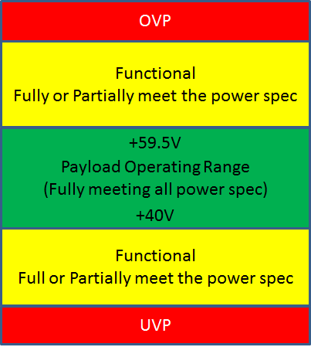

Figure 18 Protection and operation under different voltages

There are also undervoltage and overvoltage protection from the hot-swap controller which will be introduced in the late section. Usually the VR undervoltage or overvoltage protection should react after the hot-swap undervoltage or overvoltage protection.

## 6.14 Thermal Requirement

Copper distribution to each of the power rails is sized to meet max current requirements + 20% with at most a 10 degree C increase in copper temperature at max current. The temperature rise on the all the power connectors shall be limited to within 30’C.

## 6.15 Power Sequencing

Processor-specific power sequencing requirements are observed for both power up and power down.

## 6.16 Hot Swap

Hot Swap controllers allow payloads to be inserted or removed from live systems with a common or shared power bus, eliminating the need to power the system down. The basic functions of a hot-swap controller are inrush current control and fault isolation.

When boards are plugged in, the Hot Swap controller detects the voltage first, then ramps up the board’s downstream capacitors and hot swap FET gently, thereby avoiding connector sparks, backplane supply glitches and system resets. In the case of a downstream short-circuit fault, the controller’s electronic circuit breaker shuts off power to the card, preventing the fault from propagating upstream to the rest of the system. As the gateway to board power, Hot Swap Controllers have evolved from these two basic functions to also providing sophisticated board power monitoring via digital measurements of the current and voltage levels by integrated ADCs, accessible through I2C/SMBus interfaces.

### 6.16.1 Input capacitors and protection components

Capacitors shall not be placed before the hotswap MOSFET. This is to prevent spikes on the common shared system power bus during payload insertion and removal. To clamp the input voltage spike caused by the removal of the payload, a TVS is usually placed before the Hot-swap controller. To limit the input parasitic capacitance of the tray, the TVS with junction capacitance of less than 1nF is required. The selected TVS limits the voltage spike that successfully prevents the failure of the components. In practice, the TVS should also be able to handle the peak voltage up to 80V for a period of 5 to 8 microsecond.

### 6.16.2 Restart Function

The Hot-swap shall have remote restart capability (to avoid manual power reboot) for the circuit being powered. The restart function can achieved through PMBUS or it can be controlled by individual restart signal. The restart function can be achieved by controlling restart pin or UVLO, etc depending on controller.

### 6.16.3 Protection

The main function of hot swap control is to limit the inrush current during hot plug-in. It is also required to protect downstream circuit during over input voltage, under voltage, and protect the upstream from short circuit and overcurrent.

|  |  |  |
| --- | --- | --- |
| Protection | Threshold Voltage | Note |
| V_hw_Vin UVLO Threshold Rising Voltage | Vin_min +Vhys |  |
| V_hw_Vin UVLO Threshold Falling Voltage | Vin_min | 10us delay time1 |
| V_hw_Vin OVLO Threshold Rising Voltage | Vin_max | 10us delay time1 |
| V_hw_Vin OVLO Threshold Falling Voltage | Vin_max-Vhys | 10us delay time1 |
| OCP limit | Iin_max2 + 20% | hiccup mode / latch off mode 2 |
| Short Circuit Protection3 |  | response time<2us |
| OTP (for external MOSFET) |  | Auto restart. |
| Power Limit Protection |  | Desired feature: Shut down hotswap when power over limit regardless the current variation at different input voltages. |
| 1 -- Delay time can be programmed by decoupling capacitor.  2 -- Iin_max is the max continuous current from the payload  3 -- Depends on manufacturers, hot swap controller will provide option for hiccup mode or latch off mode. Latch off mode is normally chosen for short circuit protection. The best short circuit protection mode is hiccup mode with programmable reentry times. | | |

Table 1: Protection

### 6.16.4 Power Monitoring/Energy calculation

With hot swap control, current sensing is necessary to control the inrush current. Meanwhile, hotswap also has input voltage information. Since the voltage and current information already exists in the hot swap circuit, it is desired to have the hot swap controller to integrate power monitoring functions, input voltage, input current, input power and energy, which is normally associated with telemetry availability.

### 6.16.5 Telemetry

Telemetry is required for remote control and power monitoring, which is usually combined with power monitoring functions.

### 6.16.6 Power Good

PGD is necessary for system control. It is a power ready indicator, which can be used to control downstream converter.

### 6.16.7 Short Pin

In the input connector, the “short pin” shall be physically shorter than others (i.e. power pins and signal pins) on the same connector. The short pin is required to control the hot-swap enable pin, which can guarantee the power on/off sequence and avoid connector pin bouncing during plug-in and pull-out.

A 5 millisecond delay is required between disconnecting the short pin and the other pins of the 48v input connector under the condition of pulling out. This 5ms is defined in the case of fast manual removal of the payload tray.

### 6.16.8 Noise Sensitivity / Immunity

The Hot swap circuit is designed to limit the inrush current. The hot-swap controller is directly connected to input without any decoupling capacitor. Therefore, the hot-swap controller will be exposed to high noise, especially when adjacent unit plugs in or pulls out.

Hot Swapping payload on to the power bus will induce transient voltage swing, primarily related to capacitance on the payload. It is important to characterize the voltage swing incurred during the hot-swap. Such voltage fluctuation shall be kept:

* < 40 Vp-p
* < 20 ns pulse width

|  |  |  |
| --- | --- | --- |
| Noise | Spec. | Note |
| Noise on hot-swap circuit after attenuation circuit | Maximum 5V | The noise during hot plug-in or pull out can generate over 40V noise spike. This noise has to be attenuated by attenuation circuit, including TVS, inductor, etc. |

Table 2: Noise Sensitivity / Immunity

## 6.17 Firmware management

For components of the power train that require firmware or config files, version control is required to track all the releases and changes between each version. A method shall be provided to retrieve the installed version and update the firmware through application software while the system running.

## 6.18 Tray safe removal

The inductive kickback that occurs when a hot-swap shuts down due to tray removal or a fault can cause adjacent trays to reboot if they have insufficient surge immunity. Hot plug or unplug a tray shall not reset or cause failure on the adjacent tray in the rack.

As an implementation option, the risk for interference on tray removal can be reduced by disabling POL VRs before gating off the hot-swap and thus reducing the current that is interrupted by the hot-swap. The unplug sequence of events is thus:

1. Short pin in connector separates => initiates unplug sequence
2. Disable POL VRs => reduce connector current to be interrupted by hotswap
3. Disable hot-swap => bring connector current to zero
4. Power pins separate

Note that this mechanism is not effective in case of faults.

## 6.19 Compliance Requirements

The payload shall be designed for compliance to allow worldwide deployment. The 48V payload designed to work on the 48V system shall meet the following requirements when operating under typical load conditions and with all ports fully loaded. Additionally, the manufacturer is fully responsible for:

* Ensuring the complete compliance of the payload in the environment it is intended to function (as described by the Rack Spec)
* Meeting EMC requirements
* Meeting Safety requirements
* Maintaining and updating the payload and payload safety reports to current requirements and all new released requirements for as long as customer ships the payload.
* All design and re-certification costs required to update the payload to meet the new requirements.

### 6.19.1 EMC Requirements:

#### 6.19.1.1 Emissions

6dB margin from the Class A limit is required for all emission test, both radiated emission and conducted emission. When the EUT is DC powered, DC line conducted emission test is required.

Primary EMC Standards apply to emission test include, but not limited to

* FCC Part 15, Subpart B
* EN 55022: 2010 / CISPR 22: 2008 (Modified)
* EN 55032: 2012 / CISPR 32: 2012 (Modified) - Effective 05/03/2017
* EN61000-3-2: 2006/A1 : 2009/A2 : 2009
* EN61000-3-3: 2008

For DC power related testing, when applicable GR 1089 / GR 3160 may be referenced.

#### 6.19.1.2 Immunity

Primary EMC Standards apply to immunity test include, but not limited to:

* EN 55024: 2010 / CISPR 24: 2010 (Modified)
* CISPR 35: 2014
  + Current publication: CISPR/I/463/FDIS 2013-12
  + Tentative release date: October 2016

Each individual basic standard for immunity test has its specific passing requirement as illustrated below. When the EUT is DC powered, immunity test involves disturbance applied to power line apply to the DC input power.

* EN61000-4-2 Electrostatic Discharge Immunity
  + Contact discharge: >=6kV
  + Air discharge: >=8kV
* EN61000-4-3 Radiated Immunity
  + > =10V/m
* EN61000-4-4 Electrical Fast Transient Immunity
  + DC Power Line: >=2kV
  + Signal Line: >=0.5kV
* EN61000-4-5 Surge
  + DC Power Line[1]: >=1kV CM, >=0.5kV DM
  + Signal Port: >=2KV CM, >=1KVDM
* EN61000-4-6 Immunity to Conducted Disturbances
  + DC Power Line: > =10V rms
* EN61000-4-8 Power Frequency Magnetic Field Immunity, when applicable
  + > =30A/m

For DC power related testing, when applicable GR 1089 / GR 3160 may be referenced.

### 6.19.2 Safety Requirements

In addition to Sections 6.4 (Grounding), 6.5 (Safety Spacing and Keep Outs) and 6.6 (Input Fusing), the following safety requirements are to be applied.

#### 6.19.2.1 Safety Standards

The payload is to be designed to comply with the latest edition, revision, and amendment of the following standards. The payload shall be designed such that the end user could obtain the safety certifications.

* [USA] UL 60950-1, Information Technology Equipment - Safety - Part 1: General Requirements
* [CAN] CAN/CSA C22.2 No. 60950-1, Information Technology Equipment - Safety - Part 1: General Requirements
* [INT’L] IEC 60950-1, Information Technology Equipment - Safety - Part 1: General Requirements, including all national deviations as specified in the most current CB Bulletin; CB Certificate and report MUST include all countries participating in the CB Scheme; US and Canada national deviations may be excluded since the power supply will have third party certifications for these 2 countries
* [EU] EN 60950-1, Information Technology Equipment - Safety - Part 1: General Requirements
* IEC 62368-1, Audio/video, information and communication technology equipment – Part 1: Safety requirements (applicable to meet anticipated effective date of June 20, 2019 for North America and Europe.)

#### 6.19.2.2 Miscellaneous Safety and Testing Requirements

##### 6.19.2.2.1 Input Fusing

In addition to Section 6, the payload shall be furnished with a non-user replaceable fuse in the 48V positive line. The fuse must meet safety requirements of all standards and national deviations listed above.

##### 6.19.2.2.2 Materials

Acceptable payload materials include zinc plated CRS steel. Any plastic material used shall meet the appropriate flame rating specifications as note below:

* Fasteners - made of material with flammability V-0.
* Connectors - material flammability V-0, min 80C. Certified connectors preferred.
* Wiring - Wires are to be certified, rated VW-1, voltage, current, temperature rating suitable for application.
* Wiring Mechanical protection - e.g. Heat shrink tubing, braided mesh, etc. are to be certified, rated VW-1, voltage and temperature rating suitable for application.
* Printed Wiring Boards - Printed circuit board shall be UL Recognized Component, Printed Wiring Board (ZPMV2), rated V-0 and minimum 130C. Additionally it shall comply with direct support of current-carrying parts performance level requirements of ANSI/UL 796. The printed circuit board manufacturer's recognized marking and type designation shall be marked as specified on the fabrication drawing.

##### 6.19.2.2.3 Heating test

The payload shall comply with the requirements of the temperature test at an ambient of 40 degrees Celsius unless otherwise specified and discussed with appropriate Safety Engineer.

The heating test shall be done at ALL nominal and input ranges. The safety test report can be provided with the typical maximum output data, but the vendor must have test data to show the heating test was performed all input levels.

##### 6.19.2.2.4 Fault Testing

Fault testing is to be performed with a power source able to provide enough energy as available at the output of the Rack power supply. The power source shall also be able to handle inrush/turn-on current of the unit under test. During any fault testing, the payload must be protected by the internal fuse or other internal circuit or mechanism without creating a hazardous condition.

# 7.0 48V Power Shelf (rectifier and batteries)

## 7.1 Features

This spec will define the 48V power shelf that fits into the 48V Open Rack. The power shelf shall house several rectifiers or batteries with minimum of N+1 redundancy to provide the 48V dc power to all the payload inside the rack. Batteries and rectifiers can be either combined into one power shelf or separated into different individual power shelves. Single shelf or multi-power shelves shall be used in a rack depending on the power rating of the rack and power shelf.

## 7.2 Physical Requirement

### 7.2.1 Power Shelf Assembly Dimension

The nominal height of the power shelf could be multi - OUs with incremental OU increase depending on the power rating. The rack management controller could be optionally mounted within the power shelf.

Fig.19 and Fig. 20 show examples of the 48V power shelf assembly with relative positions for connectors.

Front

Top

Rear

Input connector

DC Output

Monitoring & Control Interface connector

Fig. 19 - 48V power shelf assembly

Front

Top

Rear

Input connector

Controller - Optional

DC Output

Fig. 20 - 48V power shelf assembly with controller as optional

### 7.2.2 Mounting

Power shelf will be front mounted to rack. Power shelf position can be anywhere in the rack.

### 7.2.3 Construction

Power shelf can be welded, riveted or screwed together, consistent with meeting shock, vibration and maximum allowable deflection requirements. There shall be no sharp corners or edges.

When assembled into a rack, with rectifiers installed, maximum deflection of the rectifier shelf shall be less than 1.3 mm.

### 7.2.4 Materials and Fasteners

Acceptable shelf materials include zinc plated CRS steel. Any plastic material used will meet UL 94-V0 specifications

### 7.2.5 DC Output Labeling

Labels shall be provided that identifies which DC output on the shelf is - and which is +. Label shall be an assembly aid to insure cables are assembled correctly. No text is required, rather only a label that has signs for + and - shall be sufficient.

## 7.3 Shelf Electrical Connections

### 7.3.1 Shelf input connections

The shelf input connections are for the entry of the input power to the rectifiers, so if the shelf is for batteries only, then input connections are not required. The input connection to the shelf shall be provided with off the shelf power connectors depending on the consumer's requirement.

### 7.3.2 Shelf DC connections

All components that provide the 48VDC power into the busbar:

SHALL have an output voltage with ripple & noise less than 500mV peak-to-peak with a 20MHz bandwidth. This applies along the entire length of the busbar without respect to the load or physical distribution of the trays. Compliance will be verified using a 0.1mF capacitor connected locally to the oscilloscope probe tips during this measurement. Ripple and noise are defined as periodic or random signals over a frequency band of 5Hz to 20MHz measured across a steady-state resistive load. Measurements shall be made differentially using an oscilloscope with 20Mhz bandwidth limit enabled.

The shelf DC output will be eventually connected to the bus bar in the rear side of the rack, please refer to section 2 for the bus bar information and shelf DC connection information.

### 7.3.3 Shelf Grounding

The output 48V return (negative) shall be grounded to the power shelf frame.

### 7.3.4 Monitoring & Control Interface Connector

If the rack management controller is not part of the power shelf, which is shown in fig.19, the power shelf is connected to rack management controller or facility level monitoring through a monitoring & control interface. This interface to the power shelf shall be one of

* RS-485
  + 2-wire half duplex
* CAN
  + 2-wire
* Ethernet
  + RJ45

These multi-drop serial busses can connect all the rectifiers in the shelf or across multiple shelves. This interface is used by a rack manager to control the rectifiers.

For RS485 or CAN, 2 connectors are required on a shelf to permit daisy-chaining multiple shelves.

## 7.4 Compliance Requirements

The power supply shelf shall be designed for compliance to allow worldwide deployment. Additionally, the manufacturer is fully responsible for:

* ensuring the complete compliance of the power supply shelf in the environment it is intended to function (as described by the Rack Spec)
* maintaining and updating the power supply shelf safety reports to current requirements and all new released requirements.
* all design and recertification costs required to update the power supply to meet the new
* requirements.
* Meeting EMC requirements
* Meeting Safety requirements

### 7.4.1 EMC Requirements

The 48V power shelf designed to work on the 48V system shall meet the following requirements when operating under typical load conditions and with all ports fully loaded;

#### 7.4.1.1 Emissions

6dB margin from the Class A limit is required for all emission test, both radiated emission and conducted emission. (More margin may be needed to add considering the system level integration requirement).

Primary EMC Standards apply to emission test include, but not limited to

* FCC Part 15, Subpart B
* EN 55022: 2010 / CISPR 22: 2008 (Modified)
* EN 55032: 2012 / CISPR 32: 2012 (Modified) - Effective 05/03/2017
* EN61000-3-2: 2006/A1 : 2009/A2 : 2009 / EN61000-3-12: 2011Note 1
* EN61000-3-3: 2008

Note 1: Selection of standard that defines limits for harmonic currents depends on the maximum current rating of the rectifier.

#### 7.4.1.2 Immunity

Primary EMC Standards apply to immunity test include, but not limited to

* EN 55024: 2010 / CISPR 24: 2010 (Modified)
* CISPR 35: 2014
  + Current publication: CISPR/I/463/FDIS 2013-12
  + Tentative release date: October 2016

Each individual basic standard for immunity test has its specific passing requirement as illustrated below.

* EN61000-4-2 Electrostatic Discharge Immunity
  + Contact discharge: >6kV
  + Air discharge: >8kV
* EN61000-4-3 Radiated Immunity
  + > 10V/m
* EN61000-4-4 Electrical Fast Transient Immunity
  + AC Power Line: >2kV
  + Signal Line: >0.5kV
* EN61000-4-5 Surge
  + AC Power Line: >1kV (Line-to-line), >2kV (Line-to-earth)
  + Signal Port: >2KV
* EN61000-4-6 Immunity to Conducted Disturbances
  + DC Power Line: > 10V rms
* EN61000-4-8 Power Frequency Magnetic Field Immunity, when applicable
  + > 30A/m

### 7.4.2 Safety Requirements

The manufacturer is responsible for obtaining the safety certifications specified below.

#### 7.4.2.1 Safety Standards

The unit is to be designed to comply with the latest edition, revision, and amendment of the following standards. The unit shall be designed such that the end user could obtain the safety certifications.

* UL 60950-1, Information Technology Equipment Safety Part 1: General Requirements
* CAN/CSA C22.2 No. 60950-1, Information Technology Equipment Safety Part 1: General Requirements
* IEC 60950-1, Information Technology Equipment Safety Part 1: General Requirements, including all national deviations as specified in the most current CB Bulletin; CB Certificate and report MUST include all countries participating in the CB Scheme; US and Canada national deviations may be excluded since the power supply shelf will have third party certifications for these 2 countries
* EN 60950-1, Information Technology Equipment Safety Part 1: General Requirements
* IEC 62368-1, Audio/video, information and communication technology equipment – Part 1: Safety requirements (applicable to meet anticipated effective date of June 20, 2019 for North America and Europe.)

#### 7.4.2.2 Safety Certifications and Certification Marks

The manufacturer shall obtain the following safety certifications for the power supply shelf as applicable. All evaluations must be as comprehensive as possible. Only requirements that absolutely rely on or are affected by the system may be left to the system level evaluation [i.e. minimize Conditions of Acceptability].

Below are common requirements for North America and Europe. For other countries, different certifications may be required:

* UL or an equivalent NRTL Component Recognition for the US with follow-up service (e.g. UL R/C or CSA).
* CSA Component certification for CAN with follow-up service (cUL R/C or CSA).
* CB Certificate and Test Report issued by CSA, UL, VDE, TUV or DEMKO
* CE Marking (safety and EMC) for EU

#### 7.4.2.3 Documentation

The vendor shall provide reproducible copies of all pertinent documentation relating to the following:

Product Information

* Bill of Materials
* Schematics
* functional test report

Final Compliance Approval

* NRTL certificate and report, Conditions of Acceptability and test report plus User documentation that explains safe installation and operating procedures.
* CB Certificate and report, including schematics
* Manufacturer’s Declaration of Conformity to EN 60950-1
* FCC Part 15 Class A and CISPR 22 Class A test data
* Declaration of Conformity to EN 61000-3-2 Class A and test report including waveforms and harmonic output levels.
* Bill of Materials
* Schematics

# 8.0 12V Power Shelf

# 8.1 Features

This spec will define the 12V power shelf that fits into the 12V Open Rack. The power shelf shall house several rectifiers or batteries with minimum of N+1 redundancy to provide the 12V dc power to all the payload inside the rack. Batteries and rectifiers can be either combined into one power shelf or separated into different individual power shelves. Single shelf or multi-power shelves shall be used in a rack depending on the power rating of the rack and power shelf.

## 8.2 Physical Requirement

### 8.2.1 12V Power Shelf Assembly Dimension

The nominal height of the power shelf could be multi - OUs with incremental OU increase depending on the power rating. The rack management controller could be optionally mounted within the power shelf.

Fig.21 and Fig. 22 show examples of the 12V power shelf assembly with relative positions for connectors.

Front

Top

Rear

Input connector

DC Output

Monitoring & Control Interface connector

Fig. 21 - 12V power shelf assembly

Front

Top

Rear

Input connector

Controller - Optional

DC Output

Fig. 22 - 12V power shelf assembly with controller as optional

### 8.2.2 12V Mounting

Rectifier shelf will be front mounted to rack.

### 8.2.3 12V Construction

Power shelf can be welded, riveted or screwed together, consistent with meeting shock, vibration and maximum allowable deflection requirements. There shall be no sharp corners or edges.

When assembled into a rack, with rectifiers installed, maximum deflection of the rectifier shelf shall not exit outside of the bottom of the theoretical OU.

### 8.2.4 12V Materials and Fasteners

Acceptable shelf materials include zinc plated CRS steel. Any plastic material used will meet UL 94-V0 specifications

### 8.2.5 12V DC Output Labeling

Labels shall be provided that identifies which DC output on the shelf is - and which is +. Label shall be an assembly aid to insure cables are assembled correctly. No text is required, rather only a label that has signs for + and - shall be sufficient.

## 8.3 12V Shelf Electrical Connections

### 8.3.1 12V Shelf input connections

The shelf input connections are for the entry of the input power to the rectifiers, so if the shelf is for batteries only, then input connections are not required. The input connection to the shelf shall be provided with off the shelf power connectors depending on the consumer's requirement.

### 8.3.2 Shelf 12VDC connections

All components that provide the 12VDC power into the busbar:

* SHALL have an output voltage with ripple & noise less than 120mV peak-to-peak with a 20MHz bandwidth. This applies along the entire length of the busbar without respect to the load or physical distribution of the trays. Compliance will be verified using a 0.1mF capacitor connected locally to the oscilloscope probe tips during this measurement.
* SHALL limit the amplitude of the positive and negative voltage spikes during transient-loads test between 50% to 100% of the load (10 Amps / mS) to within ±3% of the nominal output voltage (±360mV), with a response time < 1mS

The shelf DC output will be eventually connected to the bus bar in the rear side of the rack, please refer to section 2 for the bus bar information and shelf DC connection information.

### 8.3.3 12V Shelf Grounding

The output 12V return (negative) shall be grounded to the power shelf frame.

### 8.3.4 12V Monitoring & Control Interface Connector

If the rack management controller is not part of the power shelf, which is shown in fig.19, the power shelf is connected to rack management controller or facility level monitoring through a monitoring & control interface. This interface to the power shelf shall be one of

* RS-485
  + 2-wire half duplex
* CAN
  + 2-wire
* Ethernet
  + RJ45

These multi-drop serial busses can connect all the rectifiers in the shelf or across multiple shelves. This interface is used by a rack manager to control the rectifiers.

For RS485 or CAN, 2 connectors are required on a shelf to permit daisy-chaining multiple shelves.

## 8.4 12V Compliance Requirements

The power supply shelf shall be designed for compliance to allow worldwide deployment. Additionally, the manufacturer is fully responsible for:

* ensuring the complete compliance of the power supply shelf in the environment it is intended to function (as described by the Rack Spec)
* maintaining and updating the power supply shelf safety reports to current requirements and all new released requirements.
* all design and recertification costs required to update the power supply to meet the new
* requirements.
* Meeting EMC requirements
* Meeting Safety requirements

### 8.4.1 EMC Requirements

The 12V power shelf designed to work on the 12V system shall meet the following requirements when operating under typical load conditions and with all ports fully loaded;

#### 8.4.1.1 Emissions

6dB margin from the Class A limit is required for all emission test, both radiated emission and conducted emission. (More margin may be needed to add considering the system level integration requirement).

Primary EMC Standards apply to emission test include, but not limited to

* FCC Part 15, Subpart B
* EN 55022: 2010 / CISPR 22: 2008 (Modified)
* EN 55032: 2012 / CISPR 32: 2012 (Modified) - Effective 05/03/2017
* EN61000-3-2: 2006/A1 : 2009/A2 : 2009 / EN61000-3-12: 2011Note 1
* EN61000-3-3: 2008

Note 1: Selection of standard that defines limits for harmonic currents depends on the maximum current rating of the rectifier.

#### 8.4.1.2 Immunity

Primary EMC Standards apply to immunity test include, but not limited to

* EN 55024: 2010 / CISPR 24: 2010 (Modified)
* CISPR 35: 2014
  + Current publication: CISPR/I/463/FDIS 2013-12
  + Tentative release date: October 2016

Each individual basic standard for immunity test has its specific passing requirement as illustrated below.

* EN61000-4-2 Electrostatic Discharge Immunity
  + Contact discharge: >6kV
  + Air discharge: >8kV
* EN61000-4-3 Radiated Immunity
  + > 10V/m
* EN61000-4-4 Electrical Fast Transient Immunity
  + AC Power Line: >2kV
  + Signal Line: >0.5kV
* EN61000-4-5 Surge
  + AC Power Line: >1kV (Line-to-line), >2kV (Line-to-earth)
  + Signal Port: >2KV
* EN61000-4-6 Immunity to Conducted Disturbances
  + DC Power Line: > 10V rms
* EN61000-4-8 Power Frequency Magnetic Field Immunity, when applicable
  + > 30A/m

### 8.4.2 Safety Requirements

The manufacturer is responsible for obtaining the safety certifications specified below.

#### 8.4.2.1 Safety Standards

The unit is to be designed to comply with the latest edition, revision, and amendment of the following standards. The unit shall be designed such that the end user could obtain the safety certifications.

* UL 60950-1, Information Technology Equipment Safety Part 1: General Requirements
* CAN/CSA C22.2 No. 60950-1, Information Technology Equipment Safety Part 1: General Requirements
* IEC 60950-1, Information Technology Equipment Safety Part 1: General Requirements, including all national deviations as specified in the most current CB Bulletin; CB Certificate and report MUST include all countries participating in the CB Scheme; US and Canada national deviations may be excluded since the power supply shelf will have third party certifications for these 2 countries
* EN 60950-1, Information Technology Equipment Safety Part 1: General Requirements
* IEC 62368-1, Audio/video, information and communication technology equipment – Part 1: Safety requirements (applicable to meet anticipated effective date of June 20, 2019 for North America and Europe.)

#### 8.4.2.2 Safety Certifications and Certification Marks

The manufacturer shall obtain the following safety certifications for the power supply shelf as applicable. All evaluations must be as comprehensive as possible. Only requirements that absolutely rely on or are affected by the system may be left to the system level evaluation [i.e. minimize Conditions of Acceptability].

Below are common requirements for North America and Europe. For other countries, different certifications may be required:

* UL or an equivalent NRTL Component Recognition for the US with follow-up service (e.g. UL R/C or CSA).
* CSA Component certification for CAN with follow-up service (cUL R/C or CSA).
* CB Certificate and Test Report issued by CSA, UL, VDE, TUV or DEMKO
* CE Marking (safety and EMC) for EU

#### 8.4.2.3 Documentation

The vendor shall provide reproducible copies of all pertinent documentation relating to the following:

Product Information

* Bill of Materials
* Schematics
* functional test report

Final Compliance Approval

* NRTL certificate and report, Conditions of Acceptability and test report plus User documentation that explains safe installation and operating procedures.
* CB Certificate and report, including schematics
* Manufacturer’s Declaration of Conformity to EN 60950-1
* FCC Part 15 Class A and CISPR 22 Class A test data
* Declaration of Conformity to EN 61000-3-2 Class A and test report including waveforms and harmonic output levels.
* Bill of Materials
* Schematics

# 9.0 Rack Management Controller (optional)

A rack management controller can be optionally integrated into the power shelf, which is shown in fig 20. At minimum this provides an interface to monitor the rectifiers or/and batteries. For racks with more smart peripherals a more advanced rack management controller can be used to control all rack peripherals.

It worth to note that it is required that if Rack Management Controller fails, payload(s) shall be able to operate.

## 9.1 Minimum features of interface

The uplink interface to the rack management controller shall be at least 100M Fast Ethernet. The connector should be an RJ45 accessible from the front panel. The rack management controller shall be hot swappable while the rack is powered. The interface to the rectifiers can be routed internally to the shelf to minimize front panel space or using front panel cabling.

## 9.2 Preferred features of interface

To support additional peripherals (other devices in the same rack) from a single controller, the following interfaces may be supported by the rack management controller.

* RS-485 - half-duplex
* CAN - 2 wire
* Ethernet

To facilitate installation and debug at the rack level an optional front panel RS232 connector can provide a basic console (115200, 8n1). Not all management features need to be supported over this interface.

## 9.3 Interface inside power shelf with integrated rack management controller

If the rack management controller is integrated in the power shelf, the communication interface between the controller to each unit (batteries or rectifiers) or between units are not specified and not limited to the interfaces defined in section 9.2

# Appendix A - 48V Rectifier Specification with Single Phase AC input

## A.1 Features

This spec will define the single phase 48V power rectifiers that fits into the 48V power shelf. The rectifier is intended for use in a power shelf that is part of the rack, for supplying DC power to system loads. Several rectifiers with N+1 redundancy shall be included in the power shelf.

## A.2 Electrical Requirement

### A.2.1 Application

This section defines the electrical requirement for the individual rectifier.

### A.2.2 Requirements Brief Summary

* Input rated voltage 200V to 240V AC or 200V to 277Vac
* Output voltage programmable from 42V – 58 Vdc, output defaulted to 54.5V
* Capable to operating as either +48V or -48V system polarity.
* Peak efficiency> 97.0% at Vin = 230VAC, measured with fans
* Active power factor correction (meets EN/IEC 61000-3-2 and EN 60555-2 requirements)
* DC Output overvoltage and overcurrent protection
* AC Input overvoltage and undervoltage protection
* Over-temperature warning and protection
* Redundant, parallel operation with load sharing
* Hot insertion/removal (hot plug) - both rectifiers and controller unit (if any)
* Front to back air cooling
* Internally controlled variable-speed fan
* Ability to field upgrade all FW for both rectifiers and controller (if any, with bootloader) without service interruption
* All field replaceable components shall be Tool-less front side removal

### A.2.3 Electrical Requirements

#### A.2.3.1 AC Input Voltage & Frequency

The rectifier shall be capable of supplying full rated output power over single phase input voltage range of 180 – 264VAC (or 305V), and frequency of 47 – 63 Hz. Table 3 specifies the AC input voltage and frequency requirements for continuous operation.

|  |  |  |  |  |
| --- | --- | --- | --- | --- |
| **Parameter** | **Typical** | **Min** | **Max** | **Power rating (W)** |
| AC Input Voltage | 208, 230 and 240Vac (or 277Vac) | 180Vac | 264Vac (or 305Vac) | Nominal Power |
| Frequency | 60Hz | 47Hz | 63Hz | Nominal Power |

Table 3 : AC Input Voltage & Frequency Requirements

#### A.2.3.2 Start-up Sequence

The rectifier must be able to start up under rated nominal power at the min AC input voltage (180 VAC) as specified in Table 3 above. With AC present, within specified parameters, the rectifier must always remain operational. The startup sequence shall be designed such that the rectifiers are able to meet the overall system start-up time and inrush current requirements specified below.

#### A.2.3.3 Start - up / Turn on Time - Cold Start

The output voltage of the rectifier shall be monotonic during turn on and turn off, there shall not have any reverse voltage during turn off. The ramp time shall be software settable.

#### A.2.3.4 Start - up / Turn on Time - AC Failure / Recovery

The rectifier shall recover automatically after an AC power failure. The start-up time requirement shall be same as that of a cold start specified in section above.

#### A.2.3.5 Input Overvoltage and Under Voltage Protection

The maximum ac input voltage will never be above 305Vac for 240V version and 345V for 277V version continuously

The rectifier shall contain protection circuitry such that application of an input voltage below the minimum specified in Table 3 shall not cause any damage to the rectifier. The rectifier shall shut down if the input voltage is over the maximum input voltage.

#### A.2.3.6 Input Over-Current Protection

The rectifier shall incorporate primary fusing for input over-current protection to meet product safety requirements. Fuses shall be selected to prevent nuisance trips. Fuse may be internal to unit and need not be user serviceable. AC inrush current shall not cause the fuse to blow under any conditions. No rectifier operating condition shall cause the fuse to blow unless a component in the rectifier has failed. This includes DC output overload and short-circuit conditions.

#### A.2.3.7 AC Inrush Current

Maximum AC inrush current from cold power-on shall be limited to no greater than the maximum peak input current at any AC operating voltage and a temperature of 25C. This specified inrush current shall not include the X-Capacitors charging.

#### A.2.3.8 Efficiency

The efficiency of the rectifiers when measured at an AC input voltage of 230V / 60Hz and with the cooling fans connected (with input and output voltage measured at corresponding connectors, at 25C ambient and after 30 minutes running at full load) shall meet the requirements outlined in Table 4 below.

|  |  |  |
| --- | --- | --- |
| **Load Range (%)** | **Peak Efficiency (%)** | **Min Efficiency (%)** |
| 30% to 100% of full load | > 97.0% | 95% |
| 10% to 30% of full load | - | 92% |

Table 4: Efficiency Requirements

#### A.2.3.9 Power Factor

The rectifier shall incorporate an active power factor correction circuit such that the power factor exceeds 0.97 from 30% to 100% loads and when measured at AC input voltage of 230V. For loads less than 30% and down to 10% the power factor shall not be less than 0.85.

#### A.2.3.10 Total Harmonic Current Distortion (THD)

The total harmonic current distortion of each rectifier shall not exceed 5% with load higher than 50%.

#### A.2.3.11 DC Output

The DC output voltage of the rectifier shall be configurable from 42V to 58V (settable via SW), while in operation. The default set point shall be 54.5 V DC (factory default). The rectifier shall supply rated power for the entire range of DC output voltage of 48V to 58V. For the 42-48V range, the rectifier shall supply full power at 40C ambient temperature and can be derated by maximum 87.5% at higher temperatures.

#### A.2.3.12 DC Output Voltage Accuracy in Steady State

The DC output voltage shall remain within the regulation range of ±2%. This shall include all variations due to specified load range, drift, and, droop current share if implemented, and environmental conditions.

#### A.2.3.13 DC Output Voltage Ripple & Noise

The DC output voltage ripple and noise shall not exceed 500 mV peak to peak. Ripple and noise are defined as periodic or random signals over a frequency band of 5Hz to 20MHz measured across a steady-state resistive load. Measurements shall be made differentially using an oscilloscope with 20Mhz bandwidth limit enabled.

#### A.2.3.14 Dynamic Response

DC output transient response shall be measured by applying a minimum load of 10% to 50% and 50% to 100% load transient repeated at a rate of 20Hz. The slew-rate of the load transitions shall be at least 1A/uS. Under these testing conditions, the DC output voltage shall not vary by more than 2V for undershoot and overshoot.

#### A.2.3.15 Overshoot at Turn on / Turn off

The output voltage overshoot upon the application or removal of AC input voltage, under the specified input voltage defined in section 6.1, shall not exceed 2% of the set DC output voltage.

#### A.2.3.16 Hold - up Time

The rectifier shall have a hold up time of minimum of 15ms after loss of AC input voltage at 95% load. During the hold up time period, the dc voltage is allowed to go down to 41Vdc.

#### A.2.3.17 Over - Voltage Protection (OVP)

The rectifier shall shut down for DC output voltage exceeding 60V. The reacting time shall not exceed 200 msec. For DC output voltage shall never exceed 65V.

#### A.2.3.18 Output Short-circuit and Overload Protection (OCP)

The rectifier shall employ over current protection to protect the rectifier and attached load in the case of an output short-circuit or other output overload condition. This OCP (and the rectifier as a whole) must be immune to surges e.g. from tray hot plug/unplug in the rack.

#### A.2.3.19 Over Temperature Protection

The rectifier shall employ over temperature protection for both ambient over temperature and internal thermal temperature to protect the rectifier. The rectifier shall shut down under over temperature condition, and recover after certain period after the over temperature condition is removed.

#### A.2.3.20 Reverse Polarity Protection

The rectifier shall employ reverse polarity protection to protect the rectifier and attached load in the case of accidental mis-wiring. The protection shall be implemented with a short circuit hiccup mode. In this mode, if the rectifier voltage is below 10VDC, it tries to restart 3 times and then locks out.

#### A.2.3.21 Current Sharing Accuracy

With the maximum number of rectifiers connected in the system, the current sharing accuracy shall be +/- 3% or better under load > 90% and +/-­ 5% or better under load > 50%.

## A.3 Software Interface

The software interface shall be operational when the AC is present or when the DC output bus is powered up by other power sources.

* Fault conditions
  + Last power failure event
  + Rectifier failure
* Read:
  + Voltage in
  + Current in
  + Voltage out
  + Current out
  + Temperatures
  + Fan speeds
  + Power out
  + Power in
  + Position
  + Serial Number
  + Manufacturer part number
  + Hardware revision
  + Firmware revision
* Write:
  + Set output voltage setpoint (with timeout)
  + Set output current limit (with timeout)
  + Clear faults
  + Set turn-on ramp time (adjustable from 5 to 15 seconds, default is 9 seconds)
  + Set the time delay before resuming (adjustable from 2 to 5 seconds default is 2 seconds)
* Upgrades:
  + Upgrade firmware image(s)

### A.3.1 Firmware Upgrade

The interface shall allow the user to re-flash firmware on the device. Firmware upgrade shall result in no power interruption on the shelf level (the unit being upgrade can go offline.) Upgrades can be done 1 rectifier at a time.

### A.3.2 Output Voltage / Current Control

The interface shall allow the user to control output voltage and current in a single instruction on a single or all rectifiers. Valid voltage ranges are 42 to 58 volts and 0 volts. Valid current ranges are 0 to 55 amps. The rectifier shall hold up the specified voltage (voltage mode) or provide the specified current (current mode), whichever is less. In the event that a current setting necessitates an output voltage below the minimum 40V, the rectifier shall hold 40v. Note rectifier overcurrent limit shall override this in the case of a fault. Output changes shall take less than 100 milliseconds to take effect. The interface shall allow the user to specify a timeout in seconds for any given setpoint. After the time has expired the voltage shall return to previously set voltage. The timeout must include range of no less than 60*60*24 seconds.

Sample instruction:

output_setpoint(voltage[0,40-57], current[0-55], duration[0-86400], address[all or single])

### A.3.3 DC Voltage Status

The interface shall provide the current output voltage with no more than 250ms latency, no less than 0.02 volt precision and 2% accuracy.

### A.3.4 DC Current Status

The interface shall provide the current output current with no more than 250ms latency, no less than 0.1 ampere precision, and 2% accuracy.

### A.3.5 DC Energy Status

The interface shall provide the total energy delivered since interface initialization with precision no less than 1 milliwatt-hour, 3% accuracy and capacity no less than 2^64 milliwatt-hours.

### A.3.6 Last Power Failure Fault Conditions

The interface shall record and make available the total number of seconds since the last power failure event defined by one of the following conditions:

* Output voltage below 40V.
* Output voltage above 60V.
* Output current above over current protection level
* Fan failure
* Temperature > 55C

### A.3.7 Rectifier Failure

The interface shall export any condition in which a single rectifier needs servicing.

### A.3.8 Identification

The interface shall export its hardware and firmware version identification as well as a serial number uniquely identifiable to the device itself.

### A.3.9 Position

The interface shall export the position of each rectifier and ID of the shelf that it is in.

## A.4 Compliance Requirements

The power rectifier shall be designed for compliance to allow worldwide deployment. Additionally, the manufacturer is fully responsible for:

* ensuring the complete compliance of the power supply and shelf in the environment it is intended to function (as described by the Rack Spec)
* maintaining and updating the power supply and power shelf safety reports to current requirements and all new released requirements.
* all design and recertification costs required to update the power supply to meet the new requirements.
* Meeting EMC requirements
* Meeting Safety requirements

### A.4.1 EMC Requirement

The 48V rectifier designed to work on the 48V system shall meet the following requirements when operating under typical load conditions and with all ports fully loaded;

#### A.4.1.1 Emissions

6dB margin from the Class A limit is required for all emission test, both radiated emission and conducted emission. (More margin may be needed to add considering the system level integration requirement).

Primary EMC Standards apply to emission test include, but not limited to

* FCC Part 15, Subpart B
* EN 55022: 2010 / CISPR 22: 2008 (Modified)
* EN 55032: 2012 / CISPR 32: 2012 (Modified) - Effective 05/03/2017
* EN61000-3-2: 2006/A1 : 2009/A2 : 2009 / EN61000-3-12: 2011Note 1
* EN61000-3-3: 2008

Note 1: Selection of standard that defines limits for harmonic currents depends on the maximum current rating of the rectifier.

#### A.4.1.2 Immunity

Primary EMC Standards apply to immunity test include, but not limited to

* EN 55024: 2010 / CISPR 24: 2010 (Modified)
* CISPR 35: 2014
  + Current publication: CISPR/I/463/FDIS 2013-12
  + Tentative release date: October 2016

Each individual basic standard for immunity test has its specific passing requirement as illustrated below.

* EN61000-4-2 Electrostatic Discharge Immunity
  + Contact discharge: >6kV
  + Air discharge: >8kV
* EN61000-4-3 Radiated Immunity
  + > 10V/m
* EN61000-4-4 Electrical Fast Transient Immunity
  + AC Power Line: >2kV
  + Signal Line: >0.5kV
* EN61000-4-5 Surge
  + AC Power Line: >1kV (Line-to-line), >2kV (Line-to-earth)
  + Signal Port: >2KV
* EN61000-4-6 Immunity to Conducted Disturbances
  + DC Power Line: > 10V rms
* EN61000-4-8 Power Frequency Magnetic Field Immunity, when applicable
  + > 30A/m

### A.4.2 Safety Requirements

The manufacturer is responsible for obtaining the safety approvals specified below.

#### A.4.2.1 Safety Standards

The module is to be designed to comply with the latest edition, revision, and amendment of the following standards.

* UL 60950-1, Information Technology Equipment Safety Part 1: General Requirements
* CAN/CSA C22.2 No. 60950-1, Information Technology Equipment Safety Part 1: General Requirements
* IEC 60950-1, Information Technology Equipment Safety Part 1: General Requirements, including all national deviations as specified in the most current CB Bulletin; CB Certificate and report MUST include all countries participating in the CB Scheme; US and Canada national deviations may be excluded since the power supply will have third party certifications for these 2 countries
* EN 60950-1, Information Technology Equipment Safety Part 1: General Requirements
* IEC 62368-1, Audio/video, information and communication technology equipment – Part 1: Safety requirements (applicable to meet anticipated effective date of June 20, 2019 for North America and Europe.)

#### A.4.2.2 Safety Certifications and Certification Marks

The manufacturer shall obtain the following safety certifications for the power supply as applicable. All evaluations must be as comprehensive as possible. Only requirements that absolutely rely on or are affected by the system may be left to the system level evaluation [i.e. minimize Conditions of Acceptability]. Any exceptions and all Conditions of

Acceptability must be confirmed and agreed upon by Product Safety Engineer and team.

* UL or an equivalent NRTL Component Recognition for the US with follow-up service (e.g. UL R/C or CSA).
* CSA Component certification for CAN with follow-up service (cUL R/C or CSA).
* CB Certificate and Test Report issued by CSA, UL, VDE, TUV or DEMKO
* BSMI (safety and EMC) certification for Taiwan for all power supplies that are regulated by Taiwan
* CE Marking (safety and EMC) for EU

#### A.4.2.3 Documentation

The vendor shall provide reproducible copies of all pertinent documentation relating to the following:

Product Information

* Bill of Materials
* Schematics
* functional test report

Final Compliance Approval

* NRTL certificate and report, Conditions of Acceptability and test report
* CB Certificate and report, including schematics
* Manufacturer’s Declaration of Conformity to EN 60950-1
* FCC Part 15 Class A and CISPR 22 Class A test data
* Declaration of Conformity to EN 61000-3-2 Class A and test report including waveforms and harmonic output levels.
* BSMI Certificate, when appropriate

#### A.4.2.4 Miscellaneous Requirements and Tests

##### A.4.2.4.1 Input Fusing

The power supply shall be furnished with a non-user replaceable fuse in ~~the~~ each phase/live line of an AC input power supply. The fuse must meet safety requirements of all standards and national deviations listed above.

##### A.4.2.4.2 AC Input Voltage and Frequency

For safety certifications, the power supply shall be rated 200 - 240Vac, 50/60 Hz and shall operate and be evaluated with a with -/+10% tolerance.

##### A.4.2.4.3 Materials

Acceptable materials include zinc plated CRS steel. Any plastic material used is to meet UL 94-V0 specifications. Some examples of component materials are listed below:

* Fasteners - made of material with flammability V-0.
* Connectors - material flammability V-0, min 80C.
* Wiring - Wires are to be certified, rated VW-1, voltage, current, temperature rating suitable for application.
* Wiring Mechanical protection - e.g. Heat shrink tubing, braided mesh, etc. are to be certified, rated VW-1, voltage and temperature rating suitable for application.
* Printed Wiring Boards - Printed circuit board shall be UL Recognized Component, Printed Wiring Board (ZPMV2), rated V-0 and minimum 130C. Additionally it shall comply with direct support of current-carrying parts performance level requirements of ANSI/UL 796. The printed circuit board manufacturer's recognized marking and type designation shall be marked as specified on the fabrication drawing.

##### A.4.2.4.4 Secondary Circuits

All secondary circuits shall meet Safety Extra Low Voltage (SELV) requirements as described in

the safety standards listed above.

##### A.4.2.4.5 HiPot and Ground Continuity Tests

HiPot and Ground Continuity testing shall be performed by the manufacturer on the component

supply for 100% of production. The power supply unit shall pass the HiPot test without removal

or disconnection of any hardware component. The test voltage shall be as specified in the applicable safety standards listed above and latest version of IEC 50116, Information Technology Equipment – Routine Electrical Safety Testing in Production.

##### A.4.2.4.6 Humidity Test

The humidity test shall be performed as part of the power supply safety approval testing and be

included in the CB report. The test parameters shall be as specified in the applicable standards

listed above.

##### A.4.2.4.7 Capacitance Discharge Test

The capacitance discharge test shall be performed as part of the power supply safety approval

testing and be included in all safety reports. Additionally, the power supply shall be tested with the fuse in and out of the power supply circuit if the fuse is located between the bleeder resistor and x-capacitors.

##### A.4.2.4.8 Ball Pressure Test

The ball pressure test shall be performed as part of the power supply safety approval and be

included in all safety reports. This test shall be performed on all thermoplastic parts on which

hazardous voltages (> 42.4 Vpeak or > 60 VDC) are mounted (i.e. transformer bobbin, AC input

connector). Test parameters shall be as specified in IEC 60950-1.

##### A.4.2.4.9 Earthing Test

Earthing test shall be conducted in accordance with CSA C22.2 No. 0.4, Bonding and Grounding of Electrical Equipment Standard, which is referenced in UL/CSA 60950-1.

For some cases, the required test current is greater than 30 A and the required test duration is greater than two minutes.

##### A.4.2.4.10 Heating test

The power supply shall comply with the requirements of the temperature test at an ambient of 55 degrees Celsius unless otherwise specified and discussed with appropriate Product Safety Engineer. The heating test shall be done at ALL input and output combinations (including midpoints). The safety test report can be provided with the typical maximum output data, but the vendor must have test data to show the heating test was conducted at all input/output combinations. If provided, the power supply handle temperature data must also be included in the thermal test data.

***Vendor is responsible for notifying test agency to monitor and record in test report, optocoupler temperature data for all heating and abnormal operation testing. This data is required to be recorded in the safety test reports. ***

##### A.4.2.4.11 Fault Testing

Fault testing is to be performed with a minimum branch circuit protector required in the system level application. During any fault testing, no external

circuit breaker shall open. Power supply must be protected by the internal fuse or other internal

circuit or mechanism.

##### A.4.2.4.12 Abnormal Condition

The power supply shall comply with the requirements of the abnormal conditions testing as

specified in the standards listed above.

In addition, the power supply must fail safely when subjected to ambient temperatures higher than 55 degrees Celsius. This test MUST be documented in the test report.

## A.5 Environment

### A.5.1 Temperature

* Operational: 0C to +55C
* Non-operational: -40C to +85C

### A.5.2 Humidity

* Operational **:** 10-90% RH non-condensing
* Non-operational **:** 5-93% RH non-condensing

### A.5.3 Altitude

* Operationa**l :** 0-3000m
* Non-operational **:** 0-12000m

### A.5.4 Acoustic Noise

* <= 55 dBA at maximum operation point

### A.5.5 Vibration

#### A.5.5.1 Operational

Equipment must satisfy .17G vertical z-axis: .12G horizontal x- and y- axes swept from 5-500-5 Hz, 5 sweeps in all, at 1 octave/min. Reference spec (IEC 60068-2-6 Test Fc). Equipment shall be running diagnostic test while sweep is going on.

#### A.5.5.2 Non-Operational

Packaged unit must satisfy ASTM D 4169 Level 2 Schedule E using 60min Truck then 120 min Air Power Spectrum

Unpackaged unit, attached to a shaker using product's mounting points, must survive 3 hours random vibration per the following PSD Break Points.

|  |  |
| --- | --- |
| Frequency | G^2/Hz |
| 1 | .00004 |
| 4 | .00675 |
| 8 | .00759 |
| 15 | .0273 |
| 17.5 | .0102 |
| 26 | .148 |
| 34 | .000355 |
| 122 | .000006 |

Grms = .92

Table 5: Vibration Spectrum

### A.5.6 Shock

#### A.5.6.1 Operational

Equipment must satisfy 10 +/- shocks, 3.5G, 11 msec half-sine, in the x-y- and z- axes. Ref spec (IEC 60068-2-27 Test Ea). Equipment shall be running diagnostic test during shock events.

#### A.5.6.2 Non-Operational

Packaged unit must satisfy ASTM D4169 Schedule A Level 2, 6 impacts, before and after shipping vibe with the last impact at twice the height on the most typical surface to be dropped on.

Unpackaged unit, attached to a test machine using product's mounting points, must survive 3 +/- Shocks, 7.5 G, 19 msec half sine, in the vertical axis only

## A.6 Thermals

### A.6.1 Airflow Openings

The rectifier shall provide an intake and exhaust to allow front to back device cooling.

### A.6.2 Fan

Mounting of the fan must meet any vibration and acoustic criteria and will not violate any physical constraints outlined. The fan shall be included within the power supply enclosure.

### A.6.3 Fan Failure

If a fan fails, the rectifier must indicate the failure with a signal that will be reported via SW as well as an LED indicator on the front panel. The rectifier shall not need to shut down because of a failed fan and only shut down if there is a fault, ie. over-temperature fault.

### A.6.4 Temperature Sensors

The temperature sensors shall be chosen to meet the monitoring requirements and the accuracy for the sensing is within a +/- 2.0C tolerance. Exhaust and inlet temperature sensors are required in the unit.

### A.6.5 Rectifier Thermal Monitoring

Each rectifier shall provide the following parameters via the the defined communication protocol. The following thermal parameters must be available for each rectifier and labeled accordingly:

* Inlet temperature
* Exhaust temperature
* Average fan rpm (if >1 fan used in the rectifiers) percent is acceptable as long as full speed rpm is provided at some point.
* Fan fail signals

### A.6.6 Rectifier Exhaust Temperature

Maximum rectifier exhaust temp shall be 70C at back pressure between 0 and 0.05 inch H2O. While rectifier is plugged in, the rectifier fan(s) shall not get turned off even at low/idle load (due to potential high back pressure.) The rectifier design shall be able to handle back pressure up to 0.05 inch H2O.

## A.7 Reliability and Quality

### A.7.1 Derating Design

A comprehensive stress analysis and derating design shall be performed for the rectifier. The stress analysis shall include electrical, thermal, and mechanical stresses with actual measurements. The components in the rectifier design shall be properly derated and to meet the derating guideline as specified in IPC-9592B “Requirements for Power Conversion Devices for the Computer and Telecommunication Industries”, Appendix A or supplier’s own derating guideline.

### A.7.2 Reliability Prediction

A reliability prediction shall be performed for the rectifier using Telcordia SR-332 Issue 2 Method I, Case I (Part Count). The rectifier shall have a minimum MTBF= 1,000,000 hrs at 30C, 100% load per IPC-9592B without fan.

### A.7.3 Design Failure Mode and Effect Analysis (DFMEA)

A comprehensive DFMEA shall be performed for the rectifier. The DFMEA report shall include a list of critical components, risk areas, and corrective actions taken.

### A.7.4 High Accelerated Life Test (HALT)

A comprehensive HALT shall be performed on the rectifiers. The HALT equipment, testing procedure, sample size, testing report and documentation, and root cause analysis and corrective action requirements shall follow the requirements as specified in IPC-9592B, Section 5.2.3 and Appendix D.

### A.7.5 Burn-In (BI) and Ongoing Reliability Testing (ORT)

Either 100% burn-in or 100% HASS (Highly Accelerated Stress Screening) test shall be performed at the beginning of the rectifier mass production. Either BI or HASS could be chosen based on supplier’s capability and preference.

The detailed requirements for BI and HASS test durations, duration reduction plan, and test profile shall follow the requirements as specified in IPC-9592B, Appendix E for Category 1 PCD products.

After meeting the acceptable failure rate criteria as listed in Table E-1 of IPC-9592B Appendix E, the 100% BI or HASS could be reduced to sampling BI or HASA.

Ongoing Reliability Testing (ORT) shall be performed on the rectifiers when BI or HASS test is reduced from 100% to sampling and when BI or HASS is eliminated after at least one (1) year. The detailed ORT plan and requirements shall follow the requirements as specified in IPC-9592B, Appendix E, Section E.2.3.

### A.7.6 Manufacturing Quality

It is required to meet the quality process requirements as specified in IPC-9592B, Section 6 (“Quality Process”), which include PFMEA, statistical process control (SPC), corrective action process, yield control, materials traceability, product change notice (PCN), qualification of change, etc.

# Appendix B - 48V Battery Unit Spec

## B.1 Features

This document describes the requirements of a Lithium Ion battery unit used in the OCP 48V open rack. The battery unit is intended to back up the rack power during the events of power outages. Several battery units with N+1 redundancy shall be included in each rack.

## B.2 Electrical Requirement

### B.2.1 System Interface Electrical Requirements

The battery unit operates in a shared bus environment in which multiple battery units may be connected in parallel to the rack bus bar. The battery unit not only needs to meet standalone operation requirements, but also needs to meet shared bus environment requirements.

### B.2.2 Input / Output

#### B.2.2.1 Vin

This terminal is at a positive potential when voltage is measured with respect to return. Vin pin connects to the shared bus voltage. Battery unit shall be enabled over the Vin voltage range of 38V to 59.5V.

#### B.2.2.2 Return

This terminal acts as the return for the current.

#### B.2.2.3 Chassis

Chassis terminal is at 0V DC potential. Chassis and Return will be at the same potential when battery unit is installed in the power shelf that connected to shared bus system. However, the battery unit shall not have any conductive connection between return and chassis when not installed within a system. The Chassis connection inside the battery unit shall be able to withstand full rated current.

#### B.2.2.4 Short pin / Enable

The short pin connects to the +48V on the shared bus. It is used to inform the battery back that it is installed in or being removed from a rack so that it can take appropriate actions. Such actions might include enabling/disabling the power path or hot-swap circuits. Due to its shorter length, this pin connects last to the bus when battery unit is plugged into the shared bus, so that the bus voltage is already settled when battery unit is enabled. Short pin disconnects first which means battery unit is disabled before it is unplugged from the shared bus to prevent arcing. This terminal voltage range is same as the shared bus voltage (40V to 59.5V). This terminal needs to meet all the requirements specified for Vin terminal except for current rating. Current rating of the short pin/enable shall be based upon Vendor needs, but it is expected to be extremely tiny.

### B.2.3 Hot-swap

The battery unit operates in a shared bus system. The battery unit shall be hot-swappable.

### B.2.4 Inrush Current

Battery unit design shall include circuits to limit the inrush current when connecting the battery unit to the shared bus.

### B.2.5 Parallel Operation

The battery unit operates in a shared bus system. The shared bus current rating is greater than the battery unit current rating. Hence multiple battery units may be operated in parallel to address load power requirements. Battery unit shall meet all the requirements mentioned in this document both in standalone configuration and in shared bus configuration.

### B.2.6 Noise Immunity & Interference

Battery unit operates in a shared bus system. The shared bus frequently experiences voltage and current transients due to hot-swap of devices onto and off the bus. Battery unit shall be immune to shared bus transients, and also shall not cause interference to other devices.

Hot Swapping payload on to the power bus will induce transient voltage swing, primarily related to capacitance on the payload. It is important to characterize the voltage swing incurred during the hot-swap. Such voltage fluctuation shall be kept:

* < 40 Vp-p
* < 20 ns pulse width

|  |  |  |
| --- | --- | --- |
| Noise | Spec. | Note |
| Noise on hot-swap circuit after attenuation circuit | Maximum 5V | The noise during hot plug-in or pull out can generate over 40V noise spike. This noise has to be attenuated by attenuation circuit, including TVS, inductor, etc. |

Table 6: Noise Immunity and Interference

### B.2.7 Conductors, Grounding, and Isolation

Conductor sizing, spacing, materials, grounding and insulation shall comply with safety certification requirement.

Battery unit fuses, conductors, and terminals shall be designed to meet the ratings as indicated.

### B.2.8 Microcontroller(s)

The uC is responsible for operation of the battery unit. It controls the operation, diagnostics, safety functions, cell balancing, and cooling.

* uC is expected to operate primarily from Vin if present, or from battery pack as required due to fuse blown, or other conditions.

The uC is expected to monitor sensor signals, voltage levels, and current levels in the battery unit. Care shall be taken to filter (or otherwise suppress) spurious or erroneous readings such that a safe and functional battery unit is provided. The uC shall be able to detect and report blown fuses, or other possible hardware faults. The uC shall also take any necessary protective actions.

### B.2.9 Hazardous Energy

Battery unit design shall ensure that shared bus connector is isolated from power sources when the battery unit is removed from the shared bus and under fault or abnormal conditions. Even though the connector is isolated, there is a possibility that leakage voltage/current that could be present on the connector. This has to be checked in both standby and sleep state.

### B.2.10 Internal Power Supplies

Battery unit internal power supplies shall be able to operate either from Vin or from battery pack voltage. However, there shall not be any direct path between Vin and battery pack voltage under any condition.

### B.2.11 Fusing

There must be at least one fuse in the battery unit to be present on the Vin path. Where possible, these fuses shall be monitored, and if open a fault shall be reported. A fuse on the Short pin/Enable pin is not required, but if included, it must meet safety requirements of all standards and national deviations listed above. Must ensure that the components connected to the Short pin/Enable signal follow the single fault rules of safety certification requirement.

Interrupting Rating: (aka breaking capacity) fuse must have an interrupt rating equal to or greater than the maximum available instantaneous short circuit current on the shared bus bar in the rack.

### B.2.12 Voltage, Current, and Temperature Accuracy

Voltage measurement and control accuracy shall be suitable to meet all other requirements over the entire working range.

### B.2.13 Charger

Battery unit shall not draw any inrush currents in excess of charger’s limit during charger start-up or shut down. Additionally, the duration of the inrush must never exceed charger’s limit. Charger circuit shall be electrically stable under all operating conditions. The output overvoltage protection shall be included in the charger design, the overvoltage protection threshold is 60Vdc. The charge current shall be limited both to avoid exceeding rated charge current limits for the cells in the pack.

### B.2.14 DC Resistance

The series DC resistance in all paths from the shared bus connector through the battery pack and back to the shared bus connector need to be minimized to control losses.

### B.2.15 Cell Balancing

The capability of cell balancing shall be provided if applicable for battery chemistry.

### B.2.16 Discharge

Battery unit discharge path does not require any regulation. The discharge current limits to ensure that we do not exceed the rated discharge current for the cells in the pack.

### B.2.17 Operating States

#### B.2.17.1 Sleep State

Sleep state is the state that the cell discharge current is at minimum. It is enabled when Short pin / Enable voltage is below the enable threshold. The battery unit is in sleep state during transportation or anytime the battery unit is not attached to the shared bus.

#### B.2.17.2 Standby State

The battery unit is expected to be in standby state the vast majority of the time, with fully charged batteries, waiting for a discharge event.

#### B.2.17.3 Charge State

The battery unit is in charge state when it is supplying current to the battery pack in an attempt to store charge.

#### B.2.17.4 Discharge State

When the battery unit is in Discharge state, the battery pack is connected to the shared bus and it is expected that the batteries are supplying current to the shared bus.

## B.3. Firmware Interface

### B.3.1 Firmware Safety Considerations

Firmware shall maintain safe conditions for the battery, including operations, diagnostics, safety functions, cell balancing, and cooling. The battery shall be held in safe state while the uC is being reprogrammed, and reprogramming errors shall not result in unsafe conditions.

### B.3.2 Nonvolatile data

Non-volatile data shall be stored in such a way that survives microcontroller power cycling, including but not limited to removal of the control circuit board from the battery packs.

### B.3.3 Remote Firmware Upgrade

The uC shall support remote firmware upgrade without having to physically modify the device or remove it from its operating environment. Battery safety (electrical & thermal) must be guaranteed during application image flashing. The uC shall validate new firmware images and only execute images that pass the checksum. A firmware image that does not pass the checksum is assumed to be a reprogramming failure. Upon a reprogramming failure, the affected microcontroller shall remain in a safe state that is ready to receive another new firmware image.

## B.4. Safety and Compliance

### B.4.1 Safety

Battery unit shall be designed such that any failure or fault within battery unit will be completely contained within the enclosure and will not present a hazardous condition to personnel or the surrounding installation environment.

#### B.4.1.1 Electrical Abuse Tolerance

Battery unit shall withstand overvoltage up to 66V as well as short circuit with no damage and no observable safety hazard, including fumes, flames, overheating or other safety-adverse behavior. battery unit shall withstand reverse polarity connection with no safety hazard (but may suffer damage, such as blown fuse). Battery unit shall comply with abuse tolerance requirements as specified in the certification standard.

#### B.4.1.2 Cell Safety

Cells must be UL and IEC certified and safely withstand internal and external short circuit, over temperature and over charge. Cell supplier shall have demonstrated lifetime safety.

#### B.4.1.3 Battery Pack Safety

The module shall be designed and tested to prevent propagation of a hazardous cell thermal event between battery cells and between battery modules.

#### B.4.1.4 Circuit Board Safety

The high potential difference between the nominal 48V positive, negative return and GROUND nets necessitates strict spacing requirements. The concern is that manufacturing defects can result in a fault where there is a short across two nodes with a large difference in potential. The large difference in potential is defined by any voltage differential between 40V to 59.5V. This dissipation of energy can result in fire. The requirements around these high potential nets are:

* All internal layers to have a minimum of 0.64 mm clearance between signals with high potential difference
* External layers (Top and Bottom of PCB) to have a minimum of 1.5 mm clearance between signals of high potential difference if the signals are after the main board fuse from the power input connector
* External layers (Top and Bottom of PCB) to have a minimum of 3.0 mm clearance between signals of high potential difference if the signals are before the main board fuse at the input power connector, so the nominal 48V POWER and RETURN at the power input connector, for example, need to have 3.0 mm clearance.
* In the Z-axis, high potential signals before the fuse must have minimum 0.43 mm spacing or 3-ply prepreg. For signals after the fuse, minimum 0.076 mm spacing must be provided.

Exceptions may be necessary due to inherent spacing of components. These exceptions needs to be fully evaluated with DFMEA on the case by case basis.

### B.4.2 Agency Compliance

#### B.4.2.1 UL Compliance

Battery unit battery modules shall be UL Listed.

#### B.4.2.2 IEC Compliance

Battery unit shall be CB certified (certificate and test report).

### B.4.3 EMC

The 48V UPS / Battery designed to work on the 48V system shall meet the following requirements when operating under typical load conditions and with all ports fully loaded;

#### B.4.3.1 Emission

6dB margin from the Class A limit is required for all emission test, both radiated emission and conducted emission.

Primary EMC Standards apply to emission test include, but not limited to

* FCC Part 15, Subpart B
* EN 55022: 2010 / CISPR 22: 2008 (Modified)
* EN 55032: 2012 / CISPR 32: 2012 (Modified) - Effective 05/03/2017
* EN61000-3-2: 2006/A1 : 2009/A2 : 2009 / EN61000-3-12: 2011Note 1
* EN61000-3-3: 2008

Note 1: Selection of standard that defines limits for harmonic currents depends on the maximum current rating of the rectifier.

For DC power related testing, when applicable GR 1089 / GR 3160 may be referenced.

#### B.4.3.2 Immunity

Primary EMC Standards apply to immunity test include, but not limited to

* EN 55024: 2010 / CISPR 24: 2010 (Modified)
* CISPR 35: 2014
  + Current publication: CISPR/I/463/FDIS 2013-12
  + Tentative release date: October 2016

Each individual basic standard for immunity test has its specific passing requirement as illustrated below. When the EUT is DC powered, immunity test involves disturbance applied to power line apply to the DC input power.

* EN61000-4-2 Electrostatic Discharge Immunity
  + Contact discharge: >6kV
  + Air discharge: >8kV
* EN61000-4-3 Radiated Immunity
  + > 10V/m
* EN61000-4-4 Electrical Fast Transient Immunity
  + DC Power Line: >2kV
  + Signal Line: >0.5kV
* EN61000-4-5 Surge
  + DC Power Line[2]: >1kV (Line-to-line), >2kV (Line-to-earth)
  + Signal Port: >2KV CM, >1KVDM
* EN61000-4-6 Immunity to Conducted Disturbances
  + DC Power Line: > 10V rms
* EN61000-4-8 Power Frequency Magnetic Field Immunity, when applicable
  + > 30A/m

For DC power related testing, when applicable GR 1089 / GR 3160 may be referenced.

### B.4.4 Proscribed Materials

Battery unit shall be compliant with RoHS 2 directive (2011/65/EU). There is no specific additional halogen-free requirement.

## B.5 Environment

### B.5.1 Temperature

The battery unit is intended to be operated indoors with expected ambient temperatures of +15C to +45C under normal operating conditions. It will be capable of operating with full performance in ambient conditions of +20C to +35C. The battery unit shall be capable of shipping temperatures between -5C to +45C without damage or impact to life. Storage temperature shall not exceed +40C, and average storage temperature shall be below +30C.

This condition will highly depend on the data center environment, so the requirement may vary depending on the consumers.

### B.5.2 Humidity and Altitude

|  |  |  |
| --- | --- | --- |
| **Humidity** | Operating | 10-90% RH non-condensing |
|  | Non-operating | 5-93% RH non-condensing |
| **Altitude** | Operating | up to 3000m |
|  | Non-operating | Up to 12,000 meters |

Table 7: Humidity and Altitude

### B.5.3 Acoustics

There are no acoustic noise level requirements other than the battery unit shall not produce any prominent discrete tone as determined according to ISO 7779, Annex D.

### B.5.4 Mechanical Shock, Vibration and Drop

Battery unit shall shall withstand mechanical stress due to vibration, shock and drop, as applicable, suffering only allowable damage, as specified in UN 3480 (transportation safety test requirements) and safety certification requirement.

## B.6 Physical Requirements

### B.6.1 Construction

Enclosure Design requirements:

* A tool shall be required to access inside of assembly.
* No user-serviceable parts inside the assembly.
* Assembly tolerances as appropriate to ensure fault-free installation and blind mating of power, ground return.
* No sharp edges or burrs.
* Provisions for mounting all necessary components securely, to include fan, PCB(s), communications ports, battery cell blocks, absorbent materials, electrical connectors, and wiring.
* Chassis ground connection per safety certification requirement.

### B.6.2 Cooling

Cooling system shall be capable of removing heat generated by charging and other circuits while maintaining cellblock within 5C of ambient when charging or in standby states.

#### B.6.2.1 Fan Requirements

If the fan is used, then the fan control is based on the maximum battery cell temperature (Tmax). The fan ambient temperature sensor, fan tachometer, and fan speed control PWM shall be exposed to firmware interface.

## B.7 Life and Quality

### B.7.1 Expected Life

A battery unit has reached its end of useful life at the date at which it can no longer deliver the maximum power for the maximum duration at 25oC ambient.

### B.7.2 Derating

The components in the battery unit design shall be properly derated and to meet the derating guideline as specified in IPC-9592B “Requirements for Power Conversion Devices for the Computer and Telecommunication Industries”, Appendix A or supplier’s own derating guideline.

### B.7.3 Initial Quality

Initial Quality shall be >99.99% (or less than 100 Defects per million (DPM)). Defects include mechanical damage, inoperable units, units failing to deliver expected performance (power, energy) or which deliver performance which does not have adequate reserve energy and power to support expected lifetime degradation.

# Appendix C: 48V IT Tray to IT Gear Interfaces

## C.1 IT Gear Horizontal Busbar Dimensions

The IT Gear’s shelf can provide 48V power distribution and mechanical support to the server/storage/IT tray payloads utilizing a common busbar assembly profile as the rack-level busbar. Depending on the nature of the payload design, the shelf-level PDBB may or may not be utilized. IT Gear connecting directly to the rack-level busbar can either directly power IT Trays (or a single Tray) or provide horizontal pitch-agnostic power distribution via a shelf-level PDBB for multiple IT Trays.

* The shelf-level PDBB distributes power from the vertical rack-level busbars to the horizontal payload shelf
* The shelf-level PDBB will mount to the shelf to provide a power along the rear of the shelf, available for payloads to attach to power with a blind-mate interface
* The interface will provide Power, Return, and Ground
* Definition of the PDBB cross-sectional profile will drive the design of the horizontal IT Tray payload connector.

The Power and Return busbars are separated with an insulator. The chassis ground may be implemented as an additional conductor to the busbar assembly or implemented as a shelf flange with intentional fastening to chassis ground.

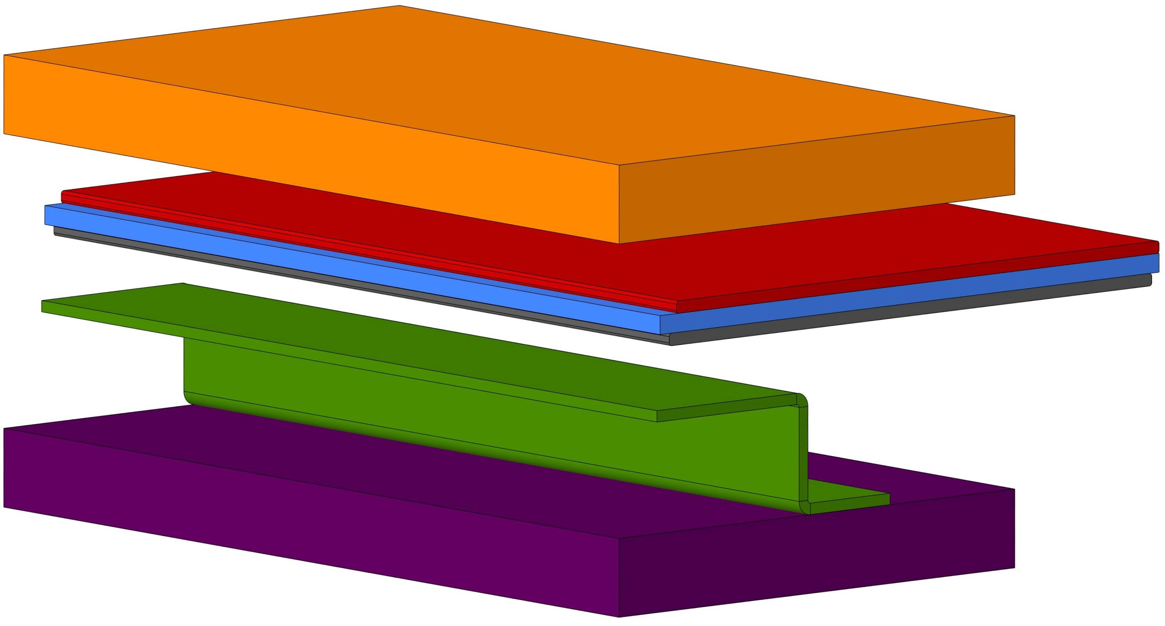

Upper boundary

Power busbar

Insulator

Return busbar

Ground

Shelf



Figure 23: Overview of busbar assembly for horizontal shelf

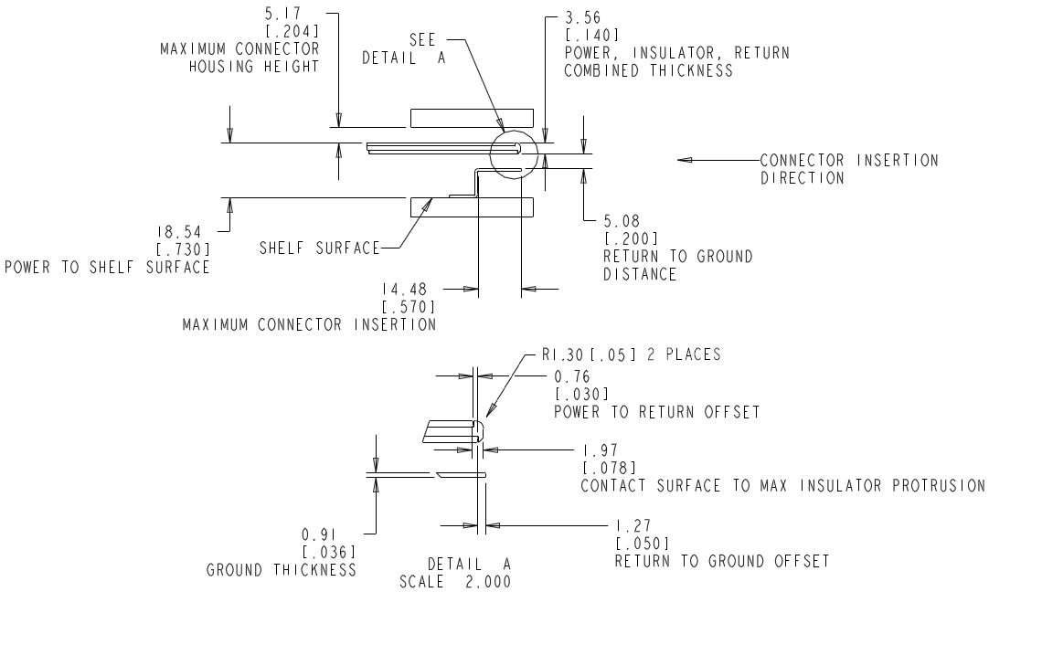

Figure 24: Overall busbar dimensions and clearances. Dimensions: mm [in]

As shown in Figure 24, the busbar assembly shall provide a rounded lead-in for connector installation. The busbar leading edge for mating shall have a minimum of a 1.3mm [0.05in] radius. This can be implemented as a molded portion of the insulator or as the profile of the busbar. Edges on the busbar facing the connector contacts must be rounded and non-rounded edges must not damage the insulator. The total stackup of the PDBB power/return busbar interface is 3.56mm±.2mm [0.140±.008in]. The connector pins shall be able to work with the contact surface of the power and return rail getting thinner and thicker throughout a RSS tolerance range of +/- 0.5mm [0.02in].

The shelf-level PDBB will connect to the rack-level busbar using a connector mounted to the shelf-level PDBB, as defined by the connector profile of the rack-level IT Gear busbar interconnect.

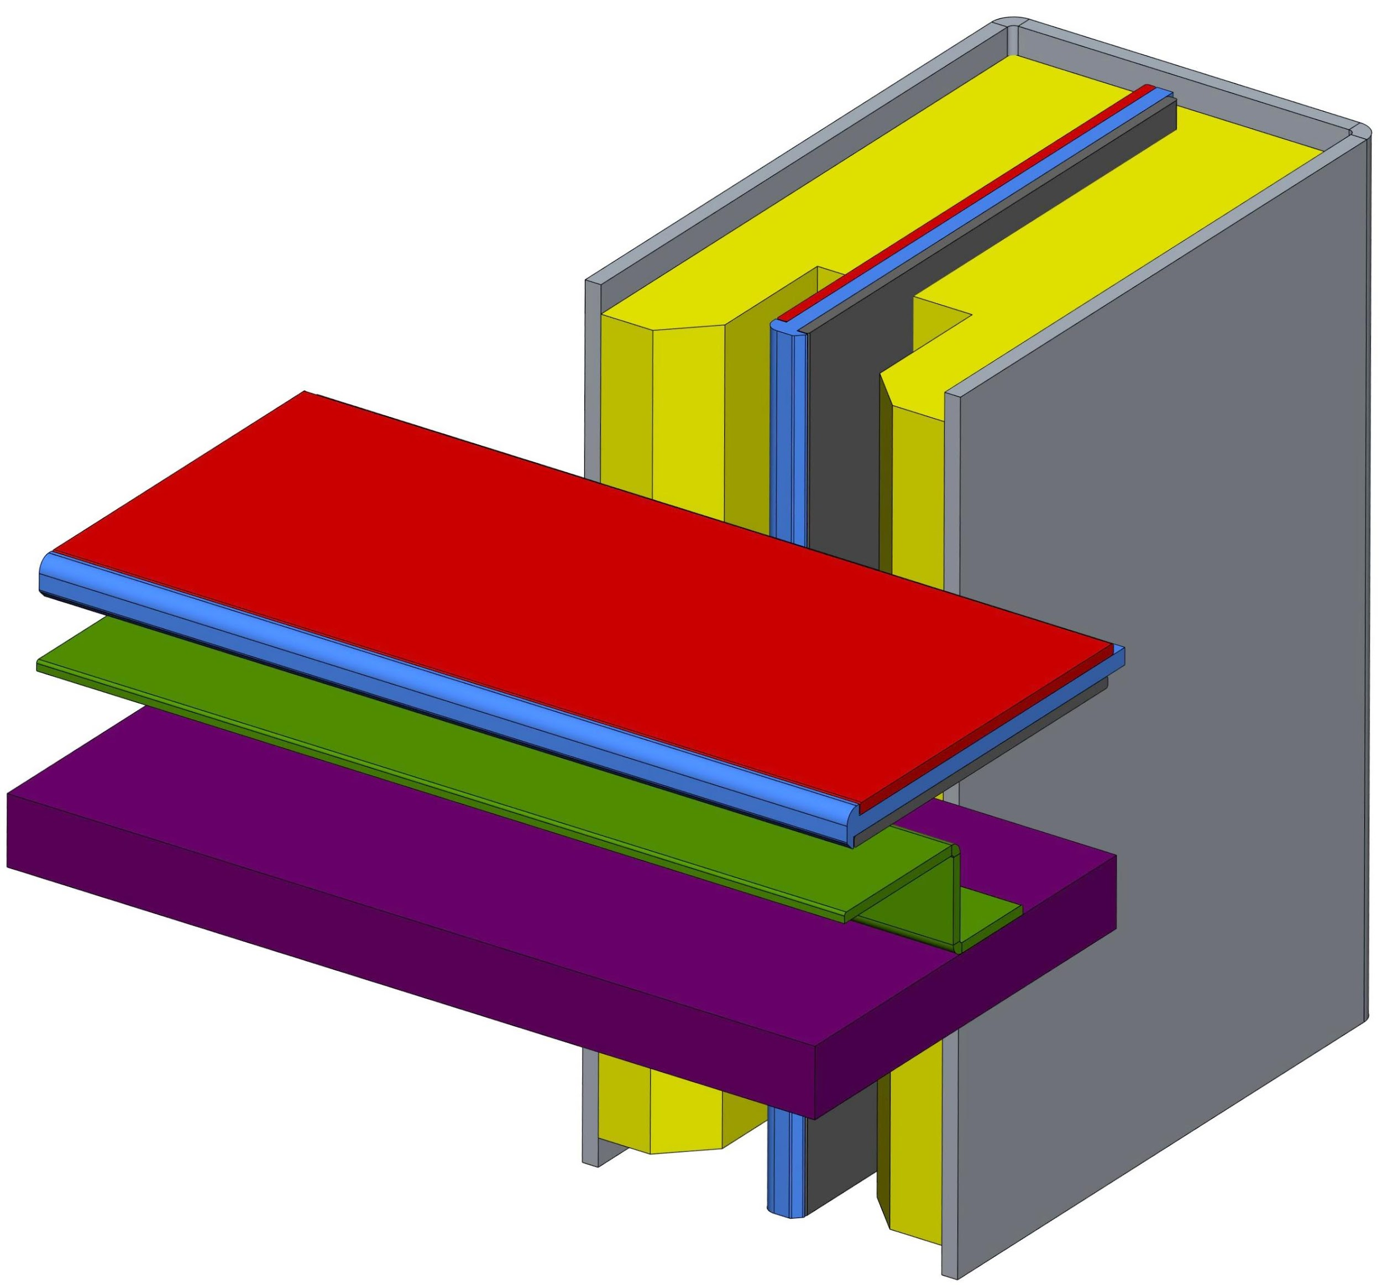

**Shelf-Level**

Power busbar

Insulator

Return busbar

Ground

Shelf

**Rack-Level**

Power busbar

Insulator

Return busbar

Insulator/Lead-in

Mount/guard

Figure 25: Example of Shelf-Level PDBB (protective cover not shown) in orthogonal position to vertical rack-level busbar.

The spacing between the busbars are defined by the leading edges of the power busbars. As shown below, the payload connector is to be located by the rear panel of the payload.

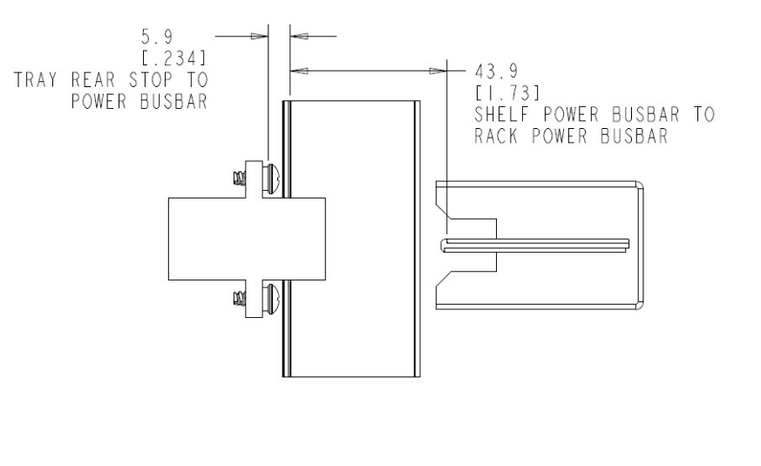

Figure 26: Top view and dimensions for IT Tray connector mated to Shelf-Level PDBB (interconnect between Shelf-Level PDBB and Rack-Level busbar not shown). Dimensions: mm [in]

## C.2 Payload IT Tray Connector

Payload IT Tray Connection to Horizontal Shelf-Level PDBB

* The Payload IT Tray connector is intended to tie payloads to a horizontal, shelf-mounted PDBB.
  + The Payload IT Tray connector is designed to be able to attach to the bus bar at any location along its length (pitch agnostic).
  + When mounted in the horizontal orientation, the connector will connect a payload to a Shelf-level horizontal PDBB within the IT Gear chassis/shelf
* The Payload IT Tray connector shall consist of 4 connection: Ground, Return, Power, and Short Pin.
  + The Power and Return contacts are to be coplanar, as contact order is determined via busbar offset
* The make sequence shall be: Ground > Return > Power > Short Pin.
* The break sequence shall be reverse of make (short pin disconnects first, then power, then return, last ground).

With the Payload IT Tray connector design, the current carrying capacity can increase with wider connector designs by increasing the contacts within the connector. The vertical dimensions are to remain constant to mate with the shelf-level PDBB.

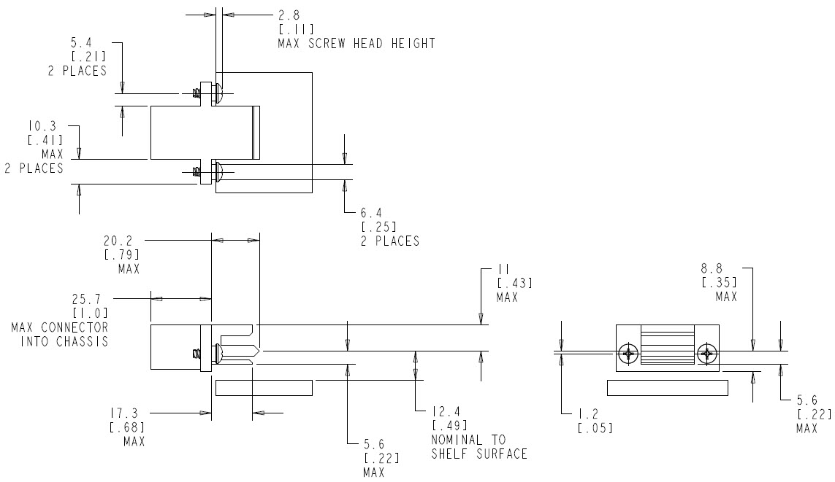

Figure 27: IT Tray Connector limits for mating with Shelf-Level PDBB. Dimensions: mm [in]

The Payload IT Tray wire mount connector shall be mountable onto a panel thickness between 1.2mm [0.048in] and 1.5mm [0.060in]. The cutouts for mounting to the panel shall provide float of +/-1mm [0.04in] in both directions to prevent damage during shipping. The connector is fastened with two 8-16 x 3/8 Inch thread forming Plastite screws.

# Appendix D: Technical guideline- Rack shielding effectiveness target and measurement procedure

## D.1 Shielding Effectiveness Measurements

The objective of this section is to provide the technical guideline for shielding effectiveness measurements of the rack. In order to insure EMC compliance to the regulatory agency limits, racks may need to be designed with optional doors and side enclosure that can provide some level of EMI shielding.

Depending on the products contained in the rack and the countries where the rack will be located, different levels of shielding may be required. Shielding effectiveness (SE) is generally defined as the ratio between the field strength, at a given distance from the source, without the shield interposed and the field strength with the shield interposed. A target shielding effectiveness can be defined by the final system integrator, **when** the rack needs to be designed to provide the EMI shielding.

## D.2 Shielding Effectiveness Measurement Methodology

The proposed measurement methodology is very similar to the methodology used for the Radiated Emission measurements according to ANSI C63.4 standard.

First a Radiated Emission Reference Level is obtained by using an RF signal source placed inside the empty rack with no shielding doors. Comb generators are the recommended RF signal source for the following SE measurement procedure. The Comb generators should have sufficient strength to be at least 20-30 dB above the noise floor, generating continuous RF signals or discrete harmonics spaced no more than 20 MHz apart. Different Comb generators may be used for different frequency ranges.

1. **Reference Level Measurement:** Eref (dBuV/m)

a. Place the empty rack on turntable in EMI chamber. All detachable doors and panels should be removed from the rack.

b. Position a Comb generator (30MHz to 1GHz) inside center of rack, 50 cm above the turntable ground plane, and with the antenna element at least 15 cm from all rack metal surfaces.

c. Measure the reference emission level, Eref (dBuV/m) from antenna at 10m distance from the source. The turntable should be rotated from 0 to 360 degrees, and the antenna should be moved between 1m to 4m height for horizontal and vertical polarizations. Record the maximum reading from spectrum analyzer.

d. The RF source used should have 20MHz (or lower) steps between 30MHz to 1GHz.

e. Change the position of the RF signal source to 1m height, and repeat c) ~e.

f. Change the position of the RF signal source to 1.5m height, and repeat c) ~e.

g. Change the signal source (Comb generator, 1GHz to 18GHz), and repeat b) ~f). For this frequency range, the receiving antenna should be located at 3m distance from the source.

2. **Rack Emission Measurement**

a. Put all doors and panels back to original position while keeping the rack at same position.

b. Repeat above steps b) ~g), and record the maximum reading, Erack (dBuV/m.

3. **SE Calculations**

Calculate SE: SE(dB) = Eref (dBuV/m) - Erack (dBuV/m).

# Revision History

|  |  |
| --- | --- |
| **Date** | **Description** |
| 10/21/2016 | * Moved 48V IT Gear Mechanical info to Appendix C * Updated 48V Bus Bar: Horizontal Lug spacing, updated tolerance stackup, added radius callouts. * Created section 9.0 12V power shelf * Updated temperature rise at rated current of busbar connector. * Updated fig.10 * Updated lifecycle of the connector * Removed “The power button shall be pressed for ~4 seconds to power off the server. When the power button is used to power off the payload, it is required that power button also be depressed to power the payload back on” in section 6.11 * Updated section 6.18 * Added rack level safety requirement * Moved 48V rectifier spec into appendix A * Moved the 48V battery unit spec into appendix B * Updated the power shelf fig. 19 and 20 * Added input voltage and current measurement accuracy for 48V rectifier spec * Removed the power module upgrade time requirement 30s in the 48V rectifier spec * Updated the temperature reporting accuracy from +/- 1C to 2C for 48V rectifier spec * Updated temperature rise limits for 48V rectifier spec * Added section 2.6 * Added power source inrush/turn on current requirement in section 6.19.2.2.4 * Corrected typo in the entire spec |
| 11/18/2016 | * Revised compliance/safety requirements as “the designed to comply with.” * Revised “ac input” as “input” on Fig. 19, 20, 21, and 22. * Section 7.2.2, added statement: Power shelf position can be anywhere in the rack. * Added Ethernet as an interface on sections 7.3.4 and 9.3.4. * Added 48V noise spec on section 7.3.2. * Updated figure numbers throughout the doc. * Changed units to metric throughout the doc. * Chapter “12V Power Shelf” was moved to chapter 8 and chapter “Rack Management Controller” was moved to chapter 9 for better document flow. * Clarified the communication protocols spec within shelf and rack. * Updated 48V Bus Bar subassembly thickness * Added Silver Plating requirement on 48V bus bar. |
| 12/5/16 | * Revised the power factor requirements for rectifier not to have a stringent requirement at light loads. * Cleared rectifier output power requirements for 42-48V dc voltage range. * Updated rectifier Dynamic Response requirement by applying a minimum load of 10% to 50% and 50% to 100% load. * Cleared rectifier hold-up time definition and requirement. * Modified the the uplink interface to the rack management controller to be at least 100M Fast Ethernet. * Revised battery to be “enabled” over the Vin voltage range of 38V to 59.5V. * FIGURE3: Change tolerance 16.5+/-0.1 and 182.2+/-1; add additional holes around the hard stop; * 4.1: changed to +/-3 vertically * Updates to 48V IT Gear connector drawings (5.2.1) * Minor updates to 48V Bus Bar stud placement (2.5.2.2) |
| 4/12/18 | * Tolerance for busbar thickness changed in FIG8 from 2x 3+/- 0.3 to 2x 3 +/-0.13 * Tolerance for Datum -A- to Hardstop distance changed in FIG3 from +/-1 to +1-0.6 * Added Appendix D. |
| 9/3/19 | * 2.3: Split FIGURE 3 into (a) and (b) options * Added FIGURE 3b. Reduced number of 5.5 dia. holes to only be located directly behind hard stop lance feature. * 2.5.1.2: Split FIGURE 9 into (a) and (b) options. * Added FIGURE 9b. Changed “M8 Stainless Clinch Nut” location from Datum -C- from 29+/-1 to 19+/-1 |

1. DC Power Line Surge test requirement is still in progress for thorough study, requirement on the level might change as the finding of the study reveal.
2. DC Power Line Surge test requirement is still in progress for thorough study, requirement on the level might change as the finding of the study reveal.